Making a Design
with Rotational Symmetry
Using a Block-Coding Program

Patterning and Algebra
Unit 3 Line Master 4a

What to Do
Click the link to access Scratch: Cat, Duck, and the Balloon: Rotationally Symmetrical Designs (Shapes & Conditional Statements):
https://scratch.mit.edu/projects/484712758/

● Select See Inside to access the code.
● Alter the code so that the design has rotational symmetry.
● Look at your code. Do you see any repeated events?
Nested events? If so, what do they create?
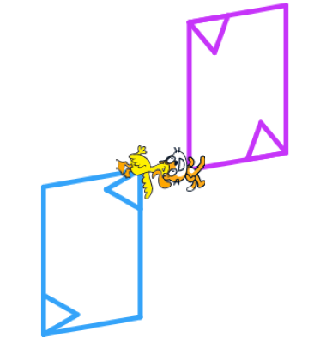
Making a Design
with Rotational Symmetry (cont’d)
Using a Block-Coding Program

Patterning and Algebra
Unit 3 Line Master 4b

Tips
● To begin, Duck’s design is slightly off the screen.
Can you alter the code to account for that?
Consider altering the Go to block’s values so Duck’s design
begins higher up on the Cartesian plane.
● Change one thing at a time. Talk about what you are changing
and why.
● Make sure the design has rotational symmetry.
● A balloon is part of this program. The balloon is there to help you
think about different aspects of this block coding program.
The balloon’s code is based on Conditional Statements
(“If … then” or If … then … else”). Try altering the conditions.
What happens when the balloon contacts the other sprites?

