**Number**

**Unit 4 Line Master 7a**

*Cross Canada Challenge!*

Gameboard

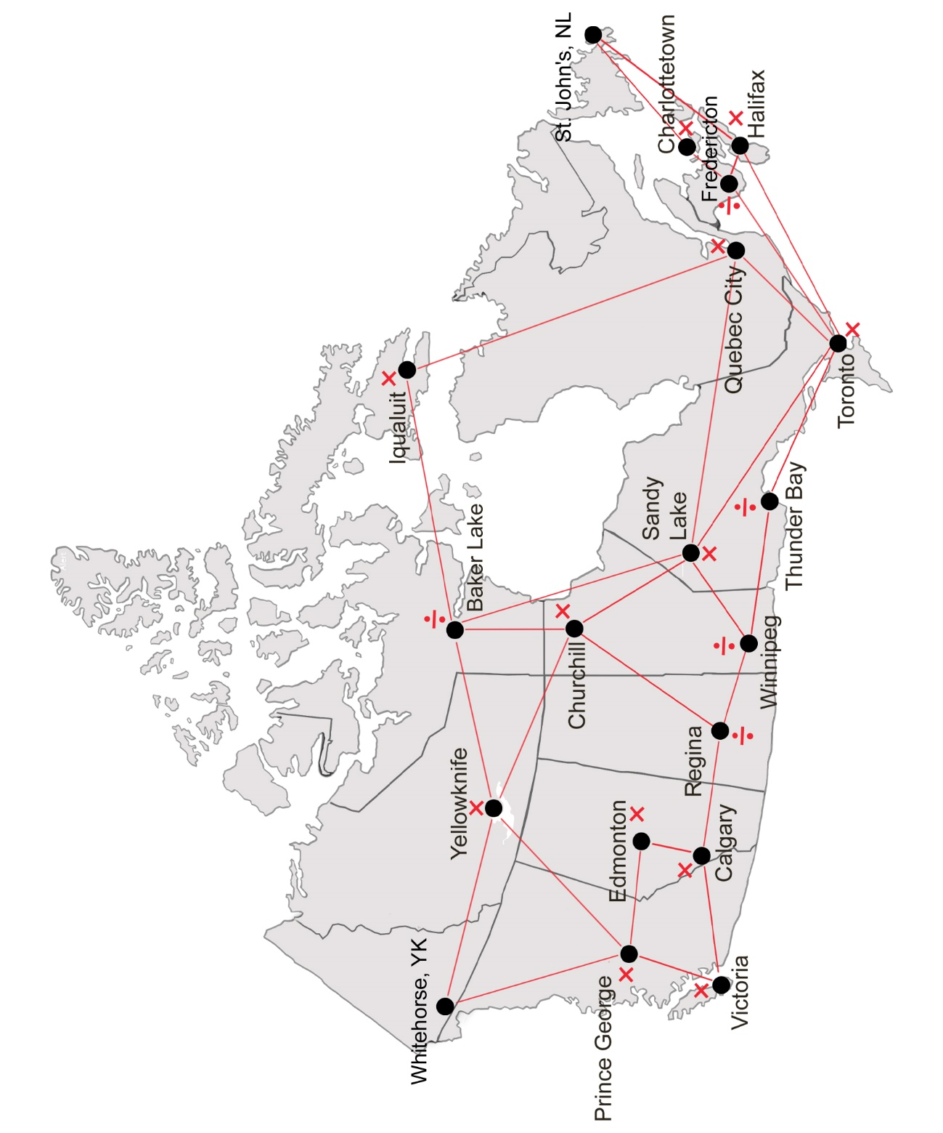

**Number**

**Unit 4 Line Master 7b**

*Cross Canada Challenge!*

Gameboard (ON only)

