Nets of 3-D Objects

**Measurement**

**Unit 1B Line Master 5a**

**Net A**

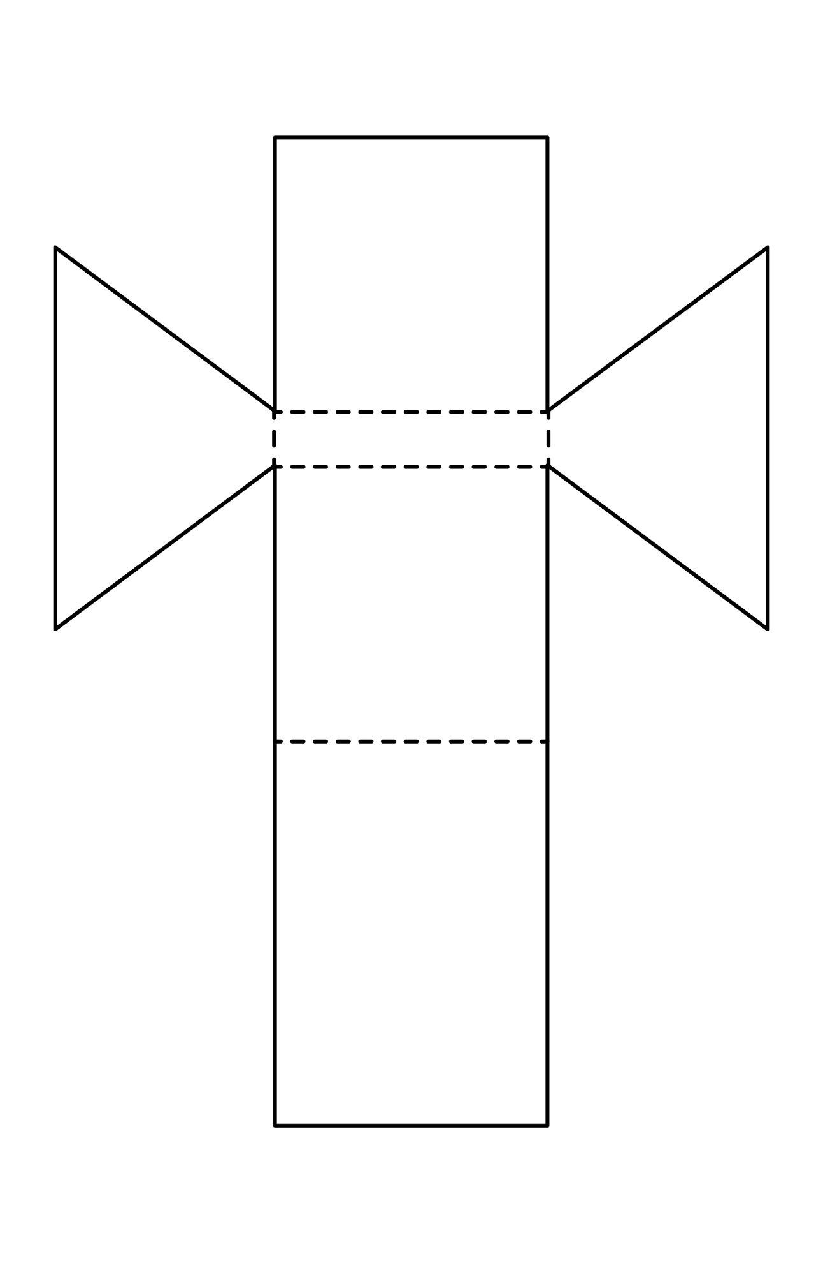

Nets of 3-D Objects (cont’d)

**Measurement**

**Unit 1B Line Master 5b**

**Net B**

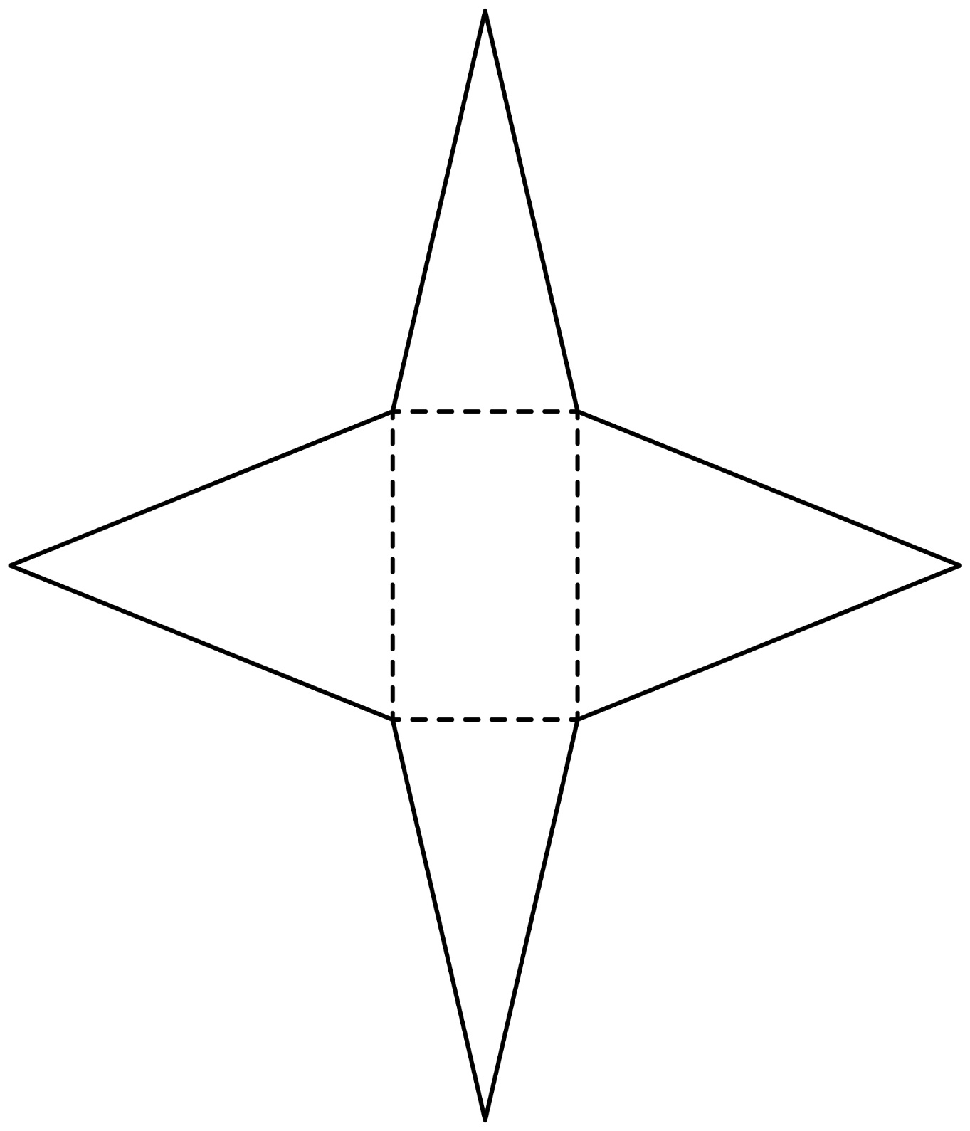

Nets of 3-D Objects (cont’d)

**Measurement**

**Unit 1B Line Master 5c**

