Area of Quadrilaterals

**Measurement**

**Unit 1B Line Master 3a**

**Rhombus**

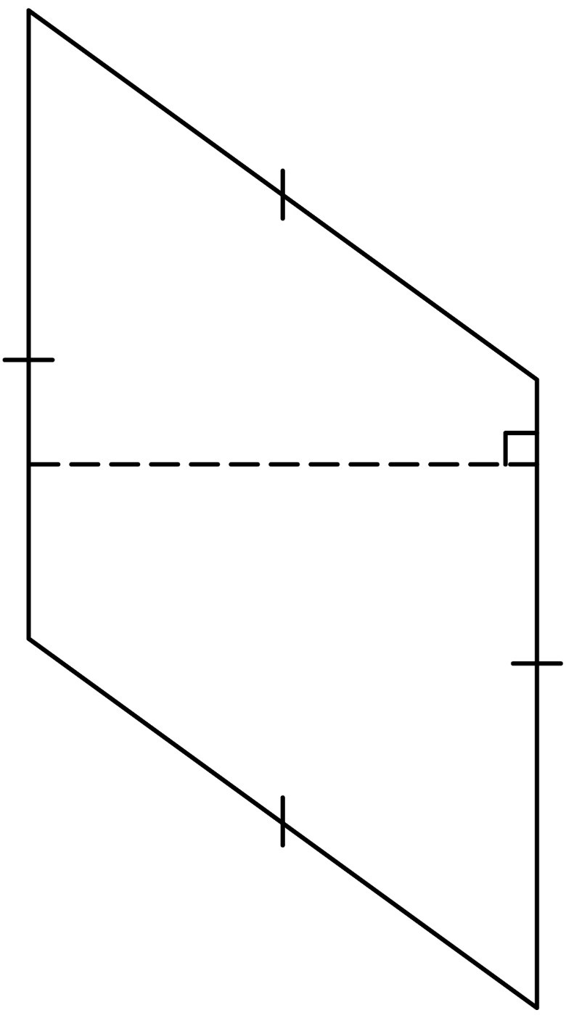

Area of Quadrilaterals (cont’d)

**Measurement**

**Unit 1B Line Master 3b**

**Trapezoid**

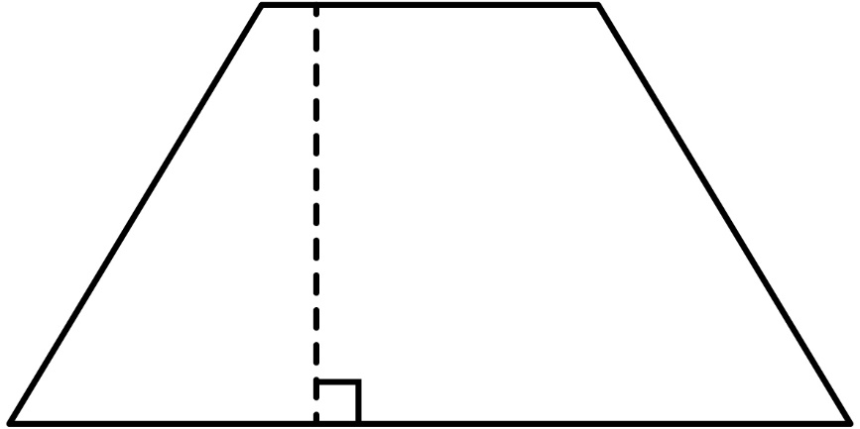

**Kite**

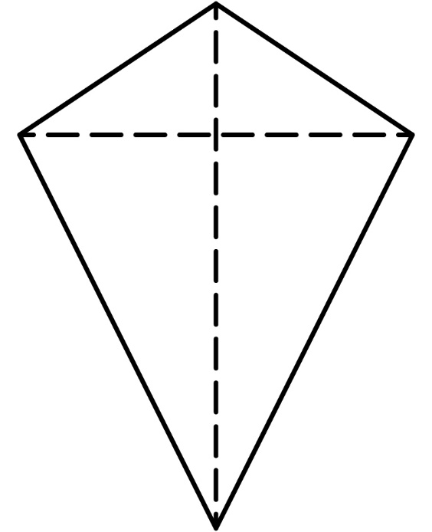

Area of Quadrilaterals (cont’d)

**Measurement**

**Unit 1B Line Master 3c**

**Dart**

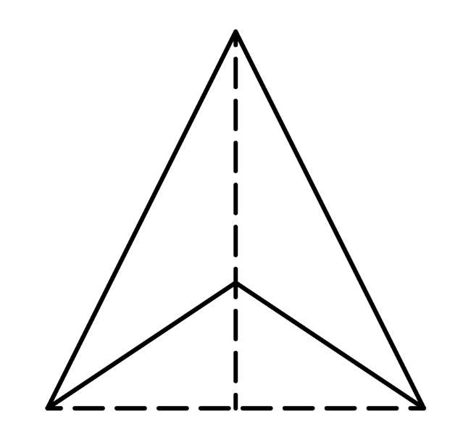

Area of Quadrilaterals (cont’d)

**Measurement**

**Unit 1B Line Master 3d**

**Rhombus**

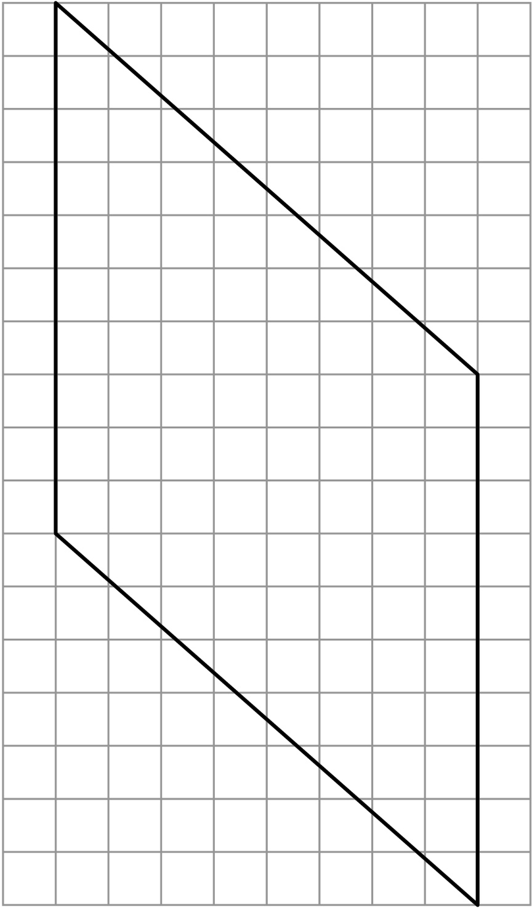

Area of Quadrilaterals (cont’d)

**Measurement**

**Unit 1B Line Master 3e**

**Trapezoid**

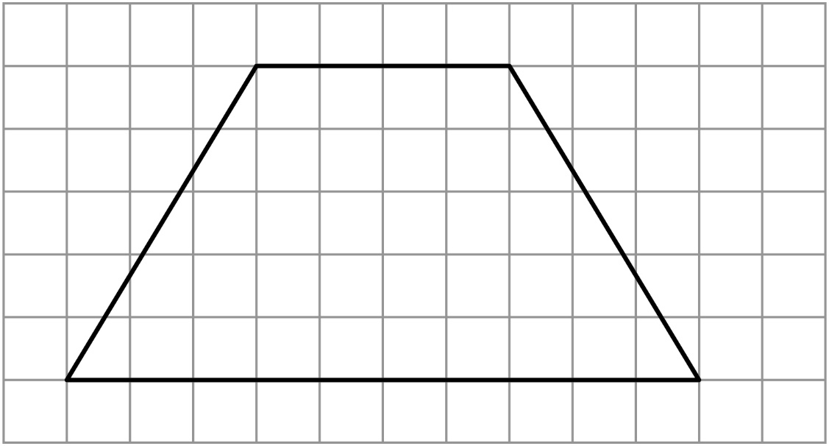

Area of Quadrilaterals (cont’d)

**Measurement**

**Unit 1B Line Master 3f**

**Kite**

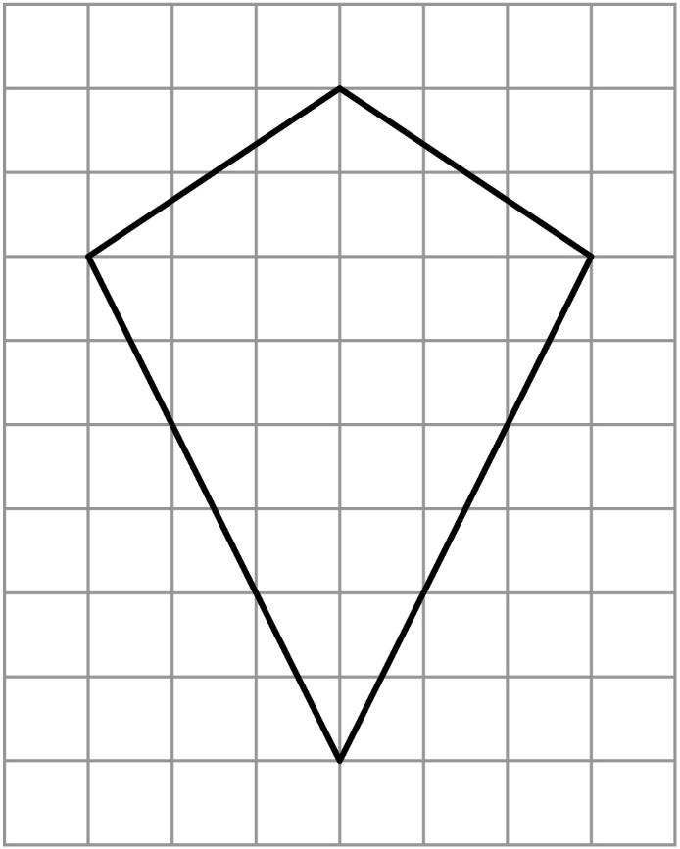

**Dart**

