Data Management
Unit 2 Line Master 2a
All Possible Outcomes

Part A
Two students tossed a coin and  spun the pointer on this spinner  to do a probability experiment  Make a tree diagram to determine  all possible outcomes. |  | 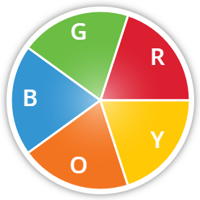

How many possible outcomes are there? How do you know?

List the outcomes in a table.

Data Management
Unit 2 Line Master 2b
All Possible Outcomes (cont’d)

Part B
Use two objects to design your own
probability experiment.

Determine all possible outcomes for
your experiment.
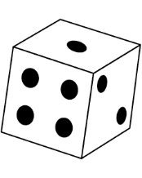

Choose one possible outcome.
Determine the theoretical probability of that outcome.
Record the probability using a fraction, decimal, or percent.

Determine the “odds in favour” of that outcome.

What do you notice about the sum of the theoretical probabilities
of an outcome occurring and not occurring? Justify your thinking.

