Data Management
Unit 2 Line Master 1a
Exploring Probability

Part A  The pointer on this spinner is spun.  Determine the probability of each outcome. | 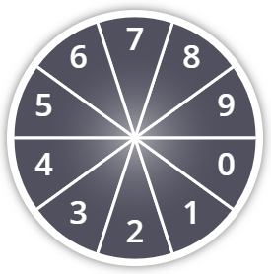

Event | Likelihood Term | Fraction | Decimal | Percent
not an even number
12
a number between 4 and 9
a number less than 3
a number less than 10

Draw a probability line. Include benchmark terms, fractions, decimals, and/or percents. Place each outcome on the line.

Data Management
Unit 2 Line Master 1b
Exploring Probability (cont’d)

Part B
Use the probability line from Part A.
Predict the results of spinning the pointer 100 times.
Event | Prediction
not an even number
12
a number between 4 and 9
a number less than 3
a number less than 10

A student conducted the experiment 100 times.
Event | Results
not an even number | 18
12 | 0
a number between 4 and 9 | 26
a number less than 3 | 6
a number less than 10 | 50

How do your predictions compare with these results?
Show the results on another probability line.

Compare the probability lines. What do you notice?
Why might this be?

