Classifying 2-D Shapes, Using Algebraic Thinking, and Conditional Statements
Reads and alters code by testing out various values or blocks until desired outcome is attained.  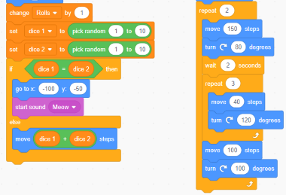  Or “In this game, if the dice are the same you go back to the start or else you add the dice.”  Or “I’m going to move the repeat 3 times block to the end and see if that works.” | Reads and alters code by visualizing and explaining the impact of changes until desired outcome is achieved.  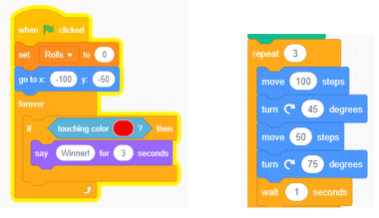  Or “This starts Cat at (–100, –50) but if the game takes too long, we could start Cat at  (0, –50) instead.”  Or “I’m going to change the degrees to 25 and 95, so they add up to 120, then it will make a hexagon. I’m also going to delete the wait because it doesn’t impact the final image.” | Flexibly alters code and makes sense of conditional statements related to outcomes and polygon classification.  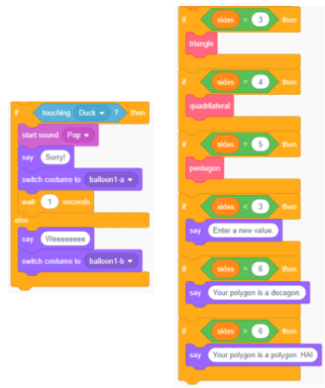  Or “I’m going to make the condition that if the Balloon is touching the Duck, it ‘pops,’ but if it’s touching the edge, it gets bigger.”  Or “I’ve created conditions for the 3- to 6-sided polygons. I will also do 7- and 8-sided polygons. Then I’ll need to change the last block  to answer > 8.”
Observations/Documentation

Classifying 2-D Shapes, Using Algebraic Thinking, and Conditional Statements (cont’d)
Uses basic blocks to write code for a  desired outcome.  “I wrote the code for my probability experiment based on the instructions for the game.” OR “I tried using these blocks, but I didn’t get  what I wanted. | Uses more complex blocks to write code for a desired outcome and considers efficiency.  “I wrote code but it had so many blocks to it. I can see that these blocks repeat. So instead, I used the repeat block and deleted these other blocks. I also included the If, then to explain what should happen to the balloon if it touches  Cat or Duck.” | Uses conditional statement blocks to write different code related to outcomes of code and  polygon classification.  “Writing code with conditional statements is like creating a flow chart. All the possibilities have to be accounted for in one way or another. The Boolean conditions help us to consider the yes/no for each possible answer, and the code also draws one of the polygons, but it may not be exactly the same unless we add more questions and set more conditions based on the answers.”
Observations/Documentation

