Solving for an Unknown in Multi-Step Equations
Uses ‘guess and check.’  28 – t = 12  “I know 28 – 8 = 20.  So, t must be more than 8.  28 – 10 = 18 (too high)  28 – 15 = 13 (too high, but close)  So, n = 16 because 28 – 16 = 12.” | Uses the balance model.  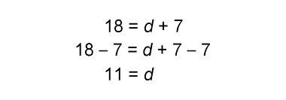  “I subtracted 7 from each side to keep the balance and to make the equation easier  to solve. | Uses relationships among operations (inverse operations, associative property).  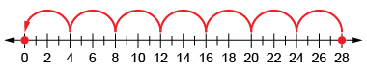  28 = 4x $∎$ + 4  “I rewrote it as a subtraction equation,  then divided both sides by 4.”  28 – 4 = 4x 24 = 4x 6 = x
Observations/Documentation

Solving for an Unknown in Multi-Step Equations (cont’d)
Uses a flow chart and inverse operations.  3d + 5 = 65  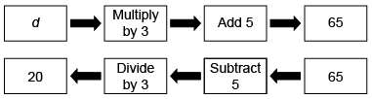  “I decomposed the equation into parts, then reversed the flow using inverse operations.” | Writes an equation with an unknown to solve  a problem.  Chico works for a dog-walking company.  Chico earns $25 a day, plus $5 for every dog he walks. On Thursday, Chico earned $70.  How many dogs did Chico walk?  “I let d represent the number of dogs  Chico walked.  I wrote the equation: 70 = 25 + 5d.” | Flexibly uses multiple strategies to  solve equations.  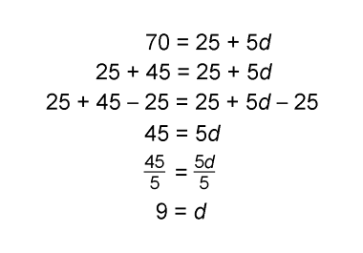  “I made the equation easier to solve by decomposing 70, subtracting 25 from each side, then dividing both sides by 5.”
Observations/Documentation

