Investigating Algebraic Expressions
Identifies the monomial represented by a model  3h + 3 = 9  “The hexagon represents h. So, the model represents 3h.” | Identifies the algebraic expression represented by a model.  “There are 2 hexagons and  6 triangles, so the design  represents 2h + 6t.” | Evaluates expressions, given the value of each variable.  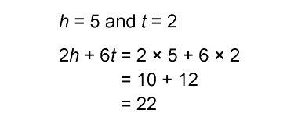  “The value of the expression is 22.” | Adds like terms to simplify an expression, then evaluates it when variables have decimal values.  Evaluate 3q + 2r + 4r + q when  q = 1.5 and r = 2.2  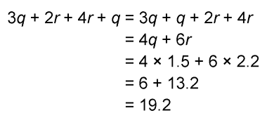  “The value of the expression  is 19.2.”
Observations/Documentation

