Generalizing and Representing Patterns
Identifies how a pattern repeats, increases, or decreases and describes the pattern rule.  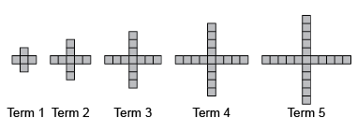  “This is an increasing pattern. The pattern rule is: Start with 5 red tiles and add 4 tiles each time.” | Represents patterns using tables, charts, or graphs and describes the pattern rule.  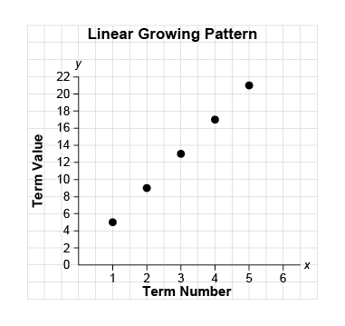  “The graph represents a growing pattern. The pattern rule is: Multiply the term number by 4 and add 1.”  Term Number Number of Blocks  1 8  2 16  3 24 | Represents patterns symbolically, using algebraic expressions and equations.  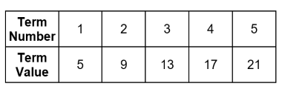  “An algebraic expression for the pattern rule: 4n + 1, where n is the term number. An equation for the pattern: v = 4n + 1, where v is the term value.” | Identifies and describes different representations of patterns as linear or non-linear.  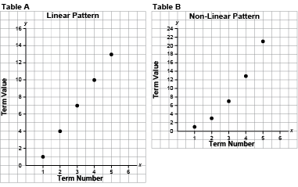  “The first graph represents a linear pattern because the points lie on a straight line. The second graph represents a non-linear pattern because the points do not lie  on a straight line.”
Observations/Documentation

Generalizing and Representing Patterns (cont’d)
Extends patterns using repeated addition and subtraction, multiplication, and division.  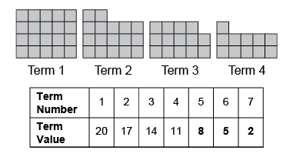  “This is a linear decreasing pattern because the same number (3) is subtracted each time. To extend the pattern, I subtract 3 from the previous term: 11 − 3 = 8, 8 − 3 = 5, 5 − 3 = 2. The term values can be represented with the expression  23 − 3n, where n is the term number.” | Creates and translates linear patterns using various representations.  Kiera has $15 to spend on items that cost $3 each.  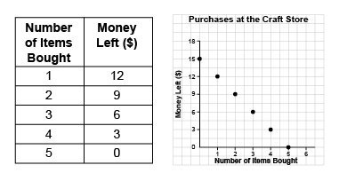  “The table shows that for each additional item bought, the money left decreases by $3. The graph shows the same linear pattern, where the money left decreases by $3 as you move from point to point.” | Uses patterns to represent and solve problems.  How far had the bus travelled after 3 h 30 min?  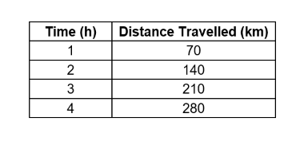  “The bus travels 70 km in 1 h  (60 min). So, in 30 min,  the bus travels 70 km ÷ 2 = 35 km.  In 3 h, the bus travels 210 km.  So, in 3 h 30 min, the bus travels 210 km + 35 km = 245 km.” | Fluently identifies, creates, and extends patterns to solve real-life problems.  How much would a 6-km ride cost?  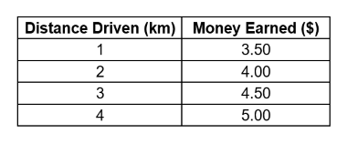  “I added 2 × $0.50 = $1.00 to the cost of a 4-km ride which is $5.00. So, a 6-km ride costs:  $5.00 + $1.00 = $6.00.  Or, I could multiply the number of kilometres by $0.50, then add $3:  6 × $0.50 + $3 = $3 + $3, or $6.”
Observations/Documentation

Number Pattern Relationships
Recognizes pattern relationships in repeating, increasing, and decreasing patterns.  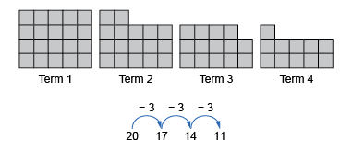  “I see a relationship that shows skip-counting backward by 3. The rule is: Start with 20 tiles and take away 3 tiles each time.” | Identifies and describes linear and non-linear patterns in tables, charts, and graphs.  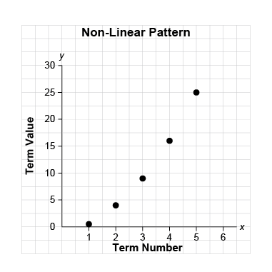  “The graph shows a non-linear increasing pattern. The points do not lie on a straight line, and a different number is added to the term value each time.” | Creates and translates repeating, increasing, and decreasing patterns using various representations.  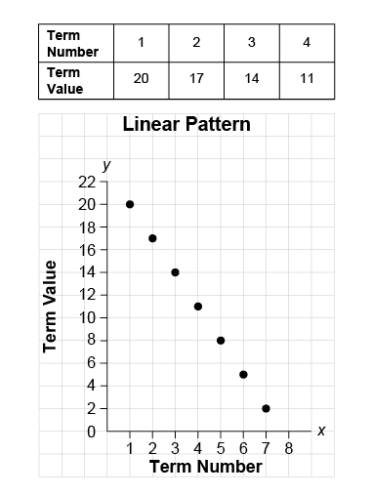  “Each of these representations shows a linear pattern that follows the pattern rule: Start at 20 and subtract 3 each time.”
Observations/Documentation

Number Pattern Relationships (cont’d)
Creates and translates repeating, increasing, and decreasing patterns and describes them using algebraic expressions and equations.  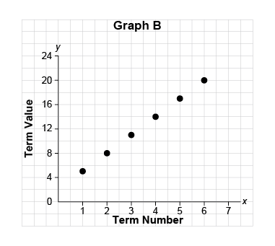  “I created this increasing pattern. An expression for the term values is: 3n + 2, where n is the term number. An equation for this pattern is:  v = 3n + 2, where v is the term value.” | Describes patterns to show relationships among whole numbers and decimals with tenths, hundredths, and thousandths.  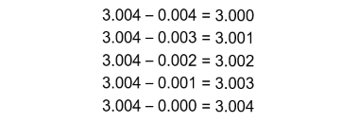  “As the number that is subtracted decreases by 0.001, the difference increases by 0.001.” | Fluently identifies and describes linear and non-linear patterns and justifies choice of representation to show pattern relationships.  Students raised $180 to buy 8 games that cost $26 each. Do they have enough money?  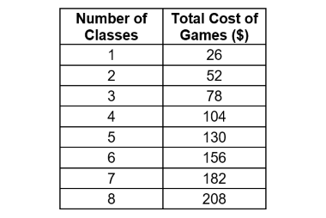  “This is a linear pattern where $26 dollars is added each time. I used the equation c = 26n to determine the cost of n games in dollars, where n = 8: c = 26 × 8, which is $208. There is not enough money to buy games for 8 classes.  Only 6 classes can have a game.”
Observations/Documentation

