Developing Fluency with Whole Number Operations
Understands number relationships and properties and applies them to whole number operations.  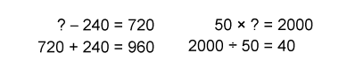  “I solved each equation using an operation I am comfortable with.” | Uses estimation to check reasonableness  of solutions.  A forklift can carry 2000 kg. An operator is unloading boxes of shoes weighing 78 kg.  How many boxes can the forklift safely carry  at one time?  78 × ? = 2000  “78 is close to 80. I know 80 × 20 = 1600 and  80 × 5 = 400. 1600 + 400 = 2000. An estimate of 25 boxes seems reasonable.” | Uses mental math strategies to solve single-step equations with larger numbers.  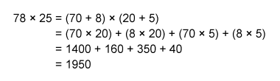  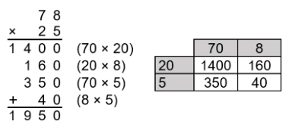  “I decomposed the numbers  to make multiplying easier.”
Observations/Documentation

Developing Fluency with Whole Number Operations (cont’d)
Solves multi-step equations using mental math strategies and properties of operations.  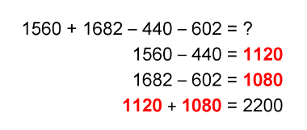 | Uses order of operations to solve equations and explains the effect when order is not followed.  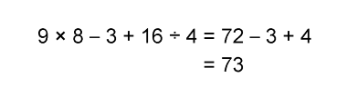  “I have to do multiplication and division first. If the order isn’t followed and I perform the operations in the order in which they appear, I get 21 R1.” | Flexibly selects mental math strategies and applies order of operations to solve multi-step equations/problems.  To claim the prize in a contest, you must answer this skill-testing question:  19 + 11 × 6 – 4 = ?  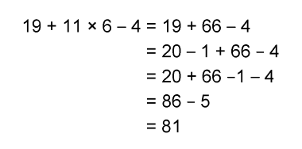
Observations/Documentation

Representing Equivalent Ratios and Rates
Represents and records ratios and rates symbolically.  10 glue sticks cost $4.  How much will 60 glue sticks cost?  For example, using rates:  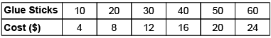  “I skip-counted by 10s and 4s.” | Represents and creates equivalent ratios and rates.  10 glue sticks cost $4.  How much will 60 glue sticks cost?  For example, using ratios:  “The ratio of glue sticks to cost is 10:4. To find the cost of 60 glue sticks, I multiply each term by 6.” | Represents and creates in-between ratios and rates.  A crafter sells 2 hand-painted pots for $18. How much will the crafter make if 7 pots are sold?  For example, using rates:  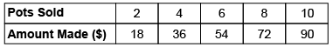  “7 is halfway between 6 and 8, so I find the number halfway between 54 and 72, which is $63.00.” | Flexibly solves problems involving ratios, including percents, and rates.  The ratio of dogs to cats in the animal shelter is 8:12. Show the comparison using percents.  “The whole is 8 + 12 = 20.  Since percent is “out of 100”,  I multiply each term in the ratio by 5 because 5 × 20 = 100.  8 × 5:12 × 5, or 40:60  40% of the animals are dogs and 60% are cats.”
Observations/Documentation

