Determining Area
Understands area as an attribute of 2-D shapes that can be measured and compared.  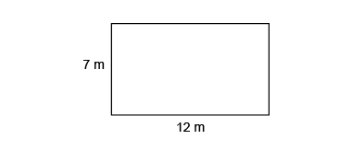  A = b × h  A = 12 m × 7 m  A = 84 m²  “I determined the area of the rectangle by multiplying the length of the base by the height.” | Determines area by decomposing shapes into smaller shapes, then adding their areas.  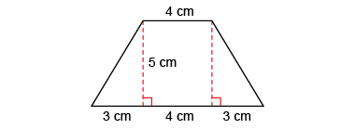  “I decomposed the trapezoid into a rectangle and 2 triangles.  Area of rectangle:  4 cm × 5 cm= 20 cm²  Area of each triangle:  3 cm × 5 cm ÷ 2 = 7.5 cm².  Area of trapezoid:  20 cm² + 7.5 cm² + 7.5 cm²  = 35 cm².” | Determines area by composing and decomposing shapes into shapes with known area formulas.  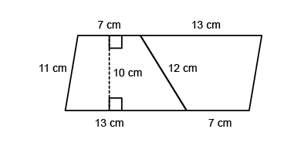  “I doubled the trapezoid to make a parallelogram.  I know the area of the trapezoid is one-half the area of the parallelogram: (13 + 7) × 10 ÷ 2  = 20 × 10 ÷ 2 = 100. The area of the trapezoid is 100 cm².” | Flexibly composes/decomposes composite polygons and irregular shapes to solve problems  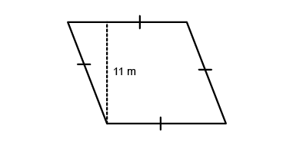  A garden is shaped like a rhombus. The perimeter of the garden is 60 m.  The height of the rhombus is 11 m.  What is the area of the garden?  “Side length of rhombus:  60 m ÷ 4 = 15 m. A rhombus is a parallelogram with all sides equal. So, to find the area of the rhombus,  I use this formula:  A = b × h; 15 m × 11 m = 165 m². The area of the garden is 165 m².”
Observations/Documentation

