Understanding Relationships Among Metric Units
Understands the relationship among metric units of mass, capacity, length, and area.  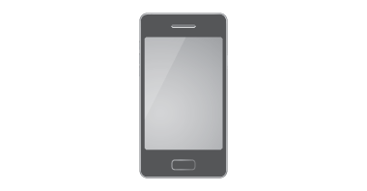  Length = 14.2 cm  “14.4 ÷ 100 = 0.142; the cell phone’s length is 14.2 cm or 0.142 m. I can visualize the phone being about 15 fingers long, but I can’t visualize 0.142 of a metre stick. I would give the length in centimetres.” | Uses metric relationships to convert from smaller to larger units to  solve problems.  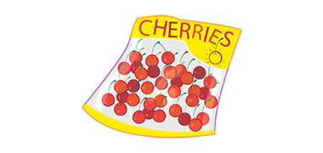  $9.00/kg  What would 300 g of cherries cost?  “I know 1 kg = 1000 g; cherries cost $9.00 per 1000 g. So, 100 g would cost $9.00 ÷10, or $0.90.  300 g would cost $0.90 × 3,  or $2.70.” | Uses metric relationships to convert from larger to smaller units to  solve problems.  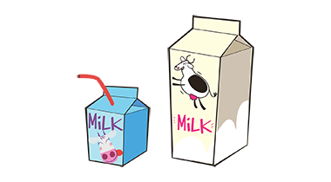  $1.25 for 250 mL $7.50 for 2 L  Which is the better deal?  “I know that 2 L = 2000 mL. It takes four 250-mL cartons to make 1 L, and eight 250-mL cartons to  make 2 L;  8 × $1.25 = $10; the 2-L carton for $7.50 is the better deal.” | Use metric relationships to estimate, measure, and solve problems.  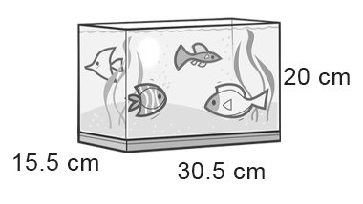  Which metric unit would you use in an ad to sell the fish tank?  “I might list the dimensions in millimetres: 155 mm by 305 mm by 200 mm because the tank may seem bigger. Reasonably, I would list the dimensions in centimetres because prospective buys would be able to relate to the units better.”
Observations/Documentation

