Measuring Area of Rectangles
Recognizes that area is the number of congruent squares needed to cover a surface.  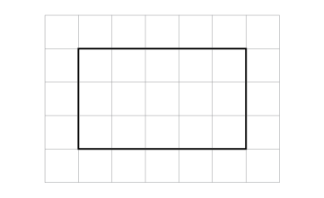  “On the 1-cm grid, the rectangle forms an array of 3 rows of 5 squares: 3 × 5 = 15; the area of the rectangle is 15 cm².” | Understands how length and width of a rectangle relate to its area and related formulas.  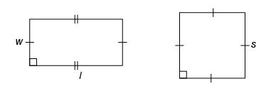  “A square has all sides equal. To determine its area, I multiply a side length by itself: A = s × s, or A = s².  To determine the area of a rectangle, I multiply the length by the width (or base by the height):  A = l × w, or A = lw, or A = b × h,  or A = bh.” | Constructs different rectangles for a given area and uses formulas to check the measures.  Area of rectangle = 16 cm²  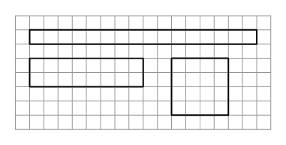  “I constructed 3 different rectangles: A square with side length 4 cm:  4 cm × 4 cm = 16 cm².  A 2-cm by 8-cm rectangle:  2 cm × 8 cm = 16 cm²  A 1-cm by 16- cm rectangle:  1 cm × 16 cm = 16 cm²” | Flexibly applies formulas to calculate the area of rectangles and to solve problems.  Cassie charges $4 for each 10 m² of driveway shovelled. How much would Cassie charge for a driveway that is 15 m by 25 m?  “Area of driveway:  15 m × 25 m = 375 m².  Determine how many 10 m²  are in the total area:  375 ÷ 10 = 37 R5.  Cassie charged:  37 × $4 + 0.5 × $4 = $148 + $2  = $150.”
Observations/Documentation

