Plotting and Reading Coordinates in Four Quadrants of the Cartesian Plane
Identifies coordinates to describe the location of points on  a Cartesian plane.  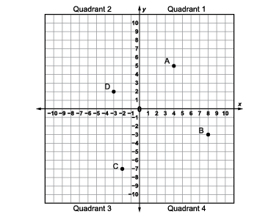  “The coordinates of point B  are (8, –3).” | Use coordinates to plot and describe the location of points on  a Cartesian plane.  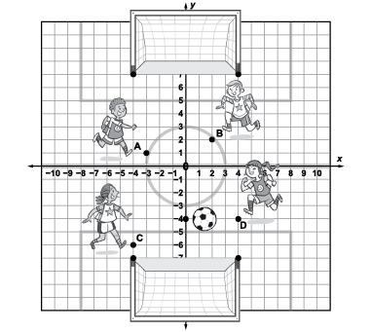  “The ends of the soccer nets are located at (–4, 7) to (4, 7) and  (–4, –7) to (4, –7)” | Describes how to translate one point to another point on  a Cartesian plane.  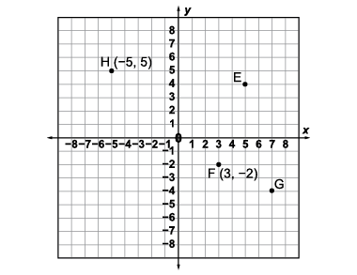  “To move point H to point F, translate point H 8 left and 7 down.”  point H(–5, 5)  (–5 + 8, 5 – 7) (3, –2) | Flexibly predicts and describes the location and coordinates of points after a translation using the translation vector.  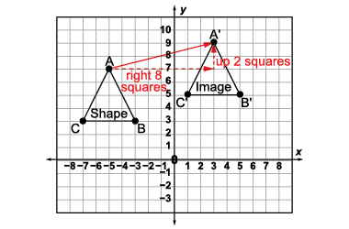  “To move point A to A’:  A(–5, 7) (–5 + 8, 7 + 2) A’(3, 9)  B(–3, 3) (–3 + 8, 3 + 2) B’(5, 5)  C(–7, 3) (–7 + 8, 3 + 2) C’(1, 5)  The translation vector is (8, 2)  for all points.”
Observations/Documentation
 | .

