Properties of Triangles
Recognizes various triangles by the number of equal sides.  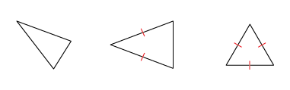  “I know the first is scalene, the second is isosceles, and the third is equilateral by looking at the number of equal sides.” | Understands that triangles can be classified by side lengths and/or angle measures.  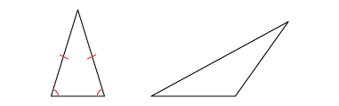  “The first triangle is an acute isosceles triangle because it has 2 equal sides and all acute angles. The second triangle is an obtuse scalene triangle because it has no equal sides and an obtuse angle.” | Constructs and identifies triangles given some side and angle measures.  ∆PQR, with PR = 5 cm,  PQ = 5 cm,  ∠P = 140°  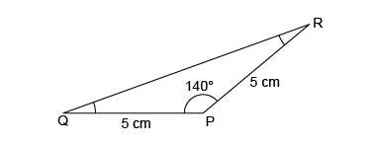  “I drew PQ = 5 cm and used a protractor to make a 140° angle at P. I drew PR = 5 cm, then connected R to Q to make the third side. Angles Q and R are each 20° because the interior angles must add to 180°.This is an obtuse isosceles triangle.” | Uses various geometric properties to determine unknown side and angle measures.  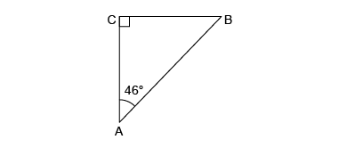  “This is an isosceles right triangle.  ∠B = 90° – 46° so ∠B = 44°.  The interior angles must add  to 180°. I know that side AC and CB are the same.”
Observations/Documentation

