Conditional Statement in Action
Master 5a

Check out this Scratch application that contains a simple conditional statement as a class. Click on the link to access the application.
https://scratch.mit.edu/projects/681175170/editor/

In this application, when the green flag is clicked to execute the code, a balloon moves to random positions around the stage. It does this 100 times, as the repeat is set to 100.

The conditional statement is inside of a repeated event, so we have something called a “nested event”, where one event – a conditional statement - is inside of another – a repeat.

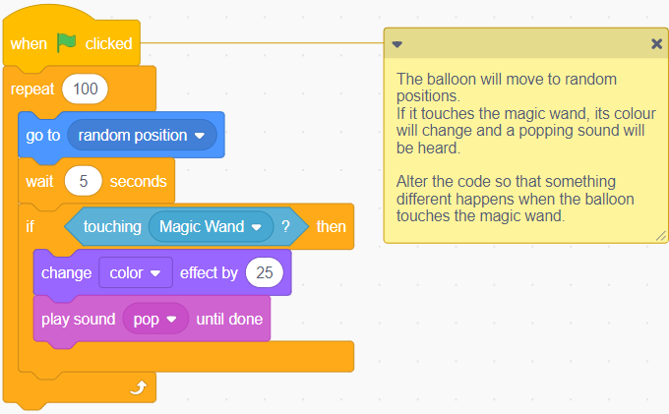

Conditional Statement in Action
Master 5b

Here is the conditional statement that we see in the Scratch code written in *pseudocode:

If the balloon is touching the magic wand then
the balloon will change colour
and a pop sound will be heard.

*Pseudocode is often used by computer programmers when they plan out their code. It is an intermediary between everyday language and coding language.

- How might you alter the code so that something different happens when the balloon touches the magic wand?

- How else might you alter the code?

