Coding Routines
Master 1a

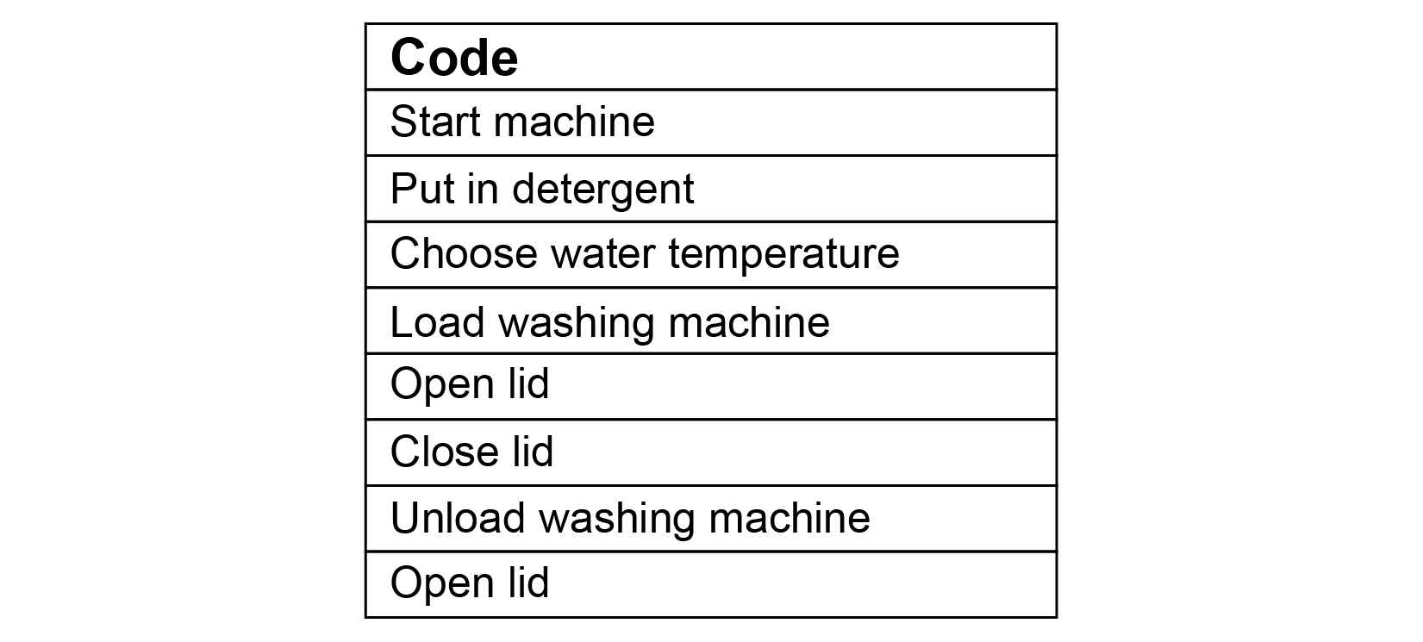
What is this code sequence for?

If this code was for doing a load of laundry at your home, would it be
in the correct order?

How might you reorganize the steps in the code so that it is accurate? Is more than one sequence possible? Explain.

When we are looking for mistakes/errors in code, we are debugging.
Do Part A of the activity.
Use the coding templates on the next page.

Coding Routines (cont’d)
Master 1b

Code: Reading a book

Code:

