Patterning Problems

Patterning and Algebra
Unit 1 Line Master 2a

Problem A
Dev records the time that his cricket team practises each week.
Dev forgot to record the time for Week 5.
There is a pattern in the practice times.
Week | Practice Time (min) | 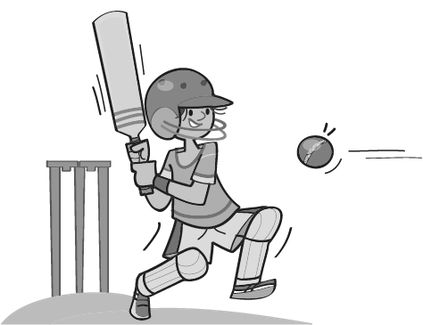
1 | 25
2 | 35
3 | 50
4 | 70
5
6 | 125

Identify the pattern rule.

What was the practice time in Week 5? How did you find out?

Suppose the pattern continues.
What would be the practice time in Week 10?
Is this reasonable? Explain.

Patterning Problems (cont’d)

Patterning and Algebra
Unit 1 Line Master 2b

Problem B
Jenna’s mom is training to be the soccer coach for Jenna’s team.
She must read the 429-page book The Ultimate Guide to Coaching
Soccer before the season starts on May 16th.
Jenna records how many pages her mom reads each day
and notices a pattern.
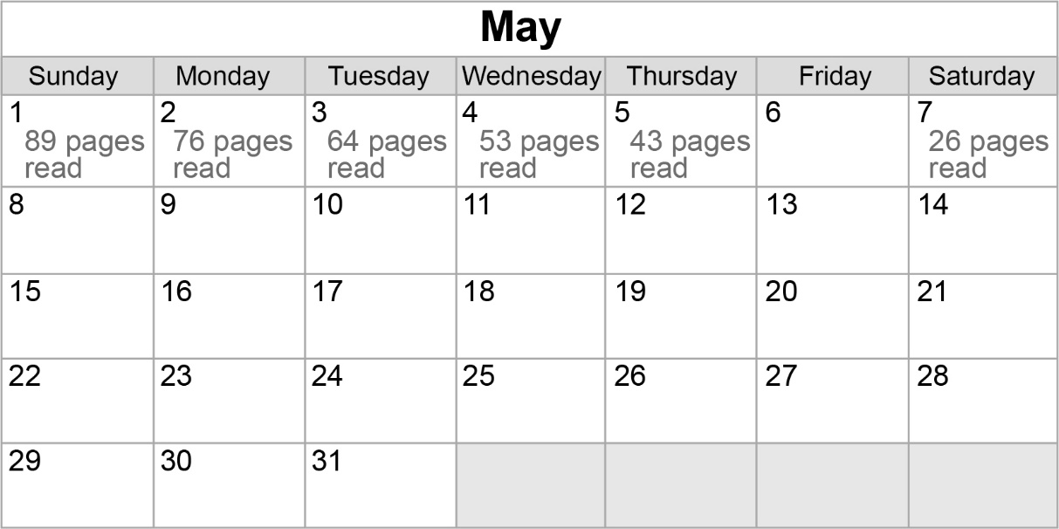
Identify the pattern rule.

Jenna accidentally erased the number of pages her mom read
on May 6th. How many pages is this?

Suppose this pattern continues.
Will Jenna’s mom finish the book in time? Explain.

