Budget Makeover!

Number
Unit 6 Line Master 10a

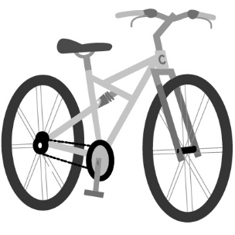
Monty, a university student, is having trouble
saving for a goal of purchasing a bicycle.
Here are Monty’s earning and spending habits.
Earnings
- Gets paid $305 per week from a part-time job
$229.99
Spending
- Buys a hot chocolate every weekday morning for $1.75
- Buys lunch from a fast-food restaurant daily ($8–$12 each time)
- Goes out with friends on Friday and Saturday nights,
spending about $25 each time
- Goes shopping for clothes/shoes, spending about $70 per week
- Subscribes to a streaming service for $119.40 per year
- Purchases a bus pass: $120 for 4 months (unlimited use)
- Buys essentials (e.g., laundry, milk, shampoo, soap): $20 per week
About how much money does Monty spend per week?

About how much money does Monety have left from his pay
each week?

What is the cost of the bicycle, including tax?

Budget Makeover! (cont’d)

Number
Unit 6 Line Master 10b

What suggestions might you make to help Monty get closer
to his goal?

Design a budget for Monty.

If Monty follows your budget, when will they be able to
purchase the bicycle?
What key factors did you consider? What tradeoffs would
you suggest?

Budget Makeover! (cont’d)

Number
Unit 6 Line Master 10c

Monty, a university student, is having trouble
saving for a goal of purchasing a bicycle.
Here are Monty’s earning and spending habits.
Earnings
- Gets paid $305 per week from a part-time job
$230
Spending
- Buys a hot chocolate every weekday morning: $10 per week
- Buys lunch from a fast-food restaurant daily: $70 per week
- Goes out with friends on Friday and Saturday nights:
$50 each weekend
- Goes shopping for clothes/shoes, spending about $70 per week
- Subscribes to a streaming service: $3 per week
- Purchases a bus pass: $8 per week (unlimited use)
- Buys essentials (e.g., laundry, milk, shampoo, soap): $20 per week
About how much money does Monty spend per week?

About how much money does Monety have left from his pay
each week?

What is the cost of the bicycle, including tax?

Budget Makeover! (cont’d)

Number
Unit 6 Line Master 10d

What suggestions might you make to help Monty get closer
to his goal?

Design a budget for Monty.

If Monty follows your budget, when will they be able to
purchase the bicycle?
What key factors did you consider? What tradeoffs would
you suggest?

