Sustainable Travel to Work
Tenths

Number
Unit 5 Line Master 3

The ways we move around our neighbourhoods affect our health
as individuals and communities. They also affect our environment.
Choose two cities.
Compare the percents of people who choose to walk, bike,
or take transit to work.
Which city travels more sustainably?
Estimate, then calculate to find exactly by how much.
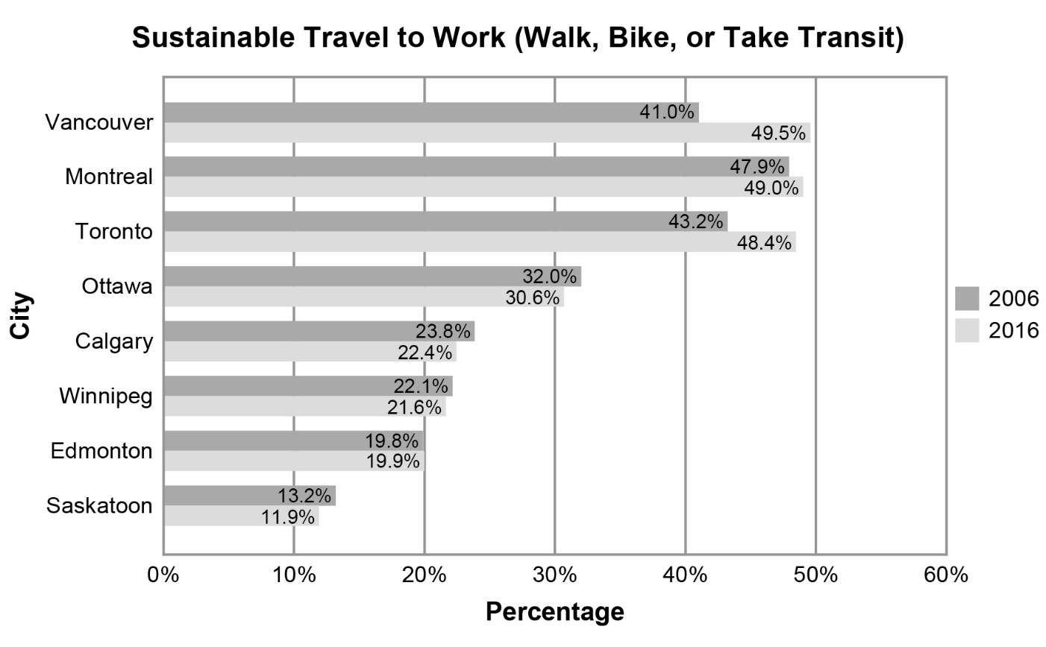
Adapted from Walking + Cycling in Vancouver (2017 Report Card)

