How Much Do It Cost?
Part B

Number
Unit 4 Line Master 4a

Solve each story problem. Show your strategy.

Problem 3
A school raised money to buy swings for some local playgrounds.
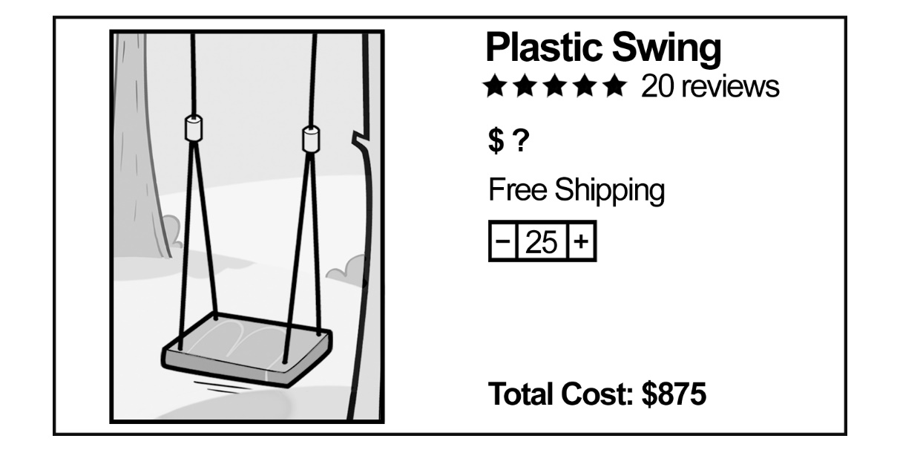
$500
What is the cost of 1 swing?

How Much Do It Cost? (cont’d)
Part B

Number
Unit 4 Line Master 4b

Problem 4
A school raised money to buy some soccer balls.
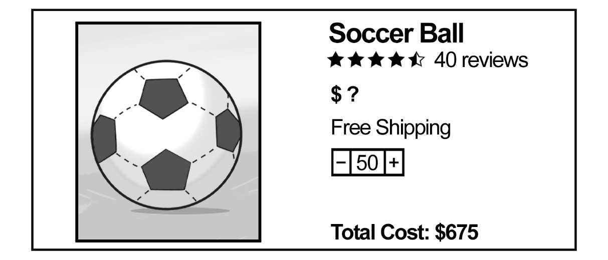
$600
What is the cost of 1 soccer ball?

