How Much Do They Eat?
Part A

Number
Unit 4 Line Master 3a

For each problem, determine how much food each animal gets.
Show your work.
Record your solution on grid paper or dot paper.

Problem 1
There are 6 grizzly bears at a wildlife park.
Each day, they receive a 120-kg bag of food.
The food is shared equally among them.
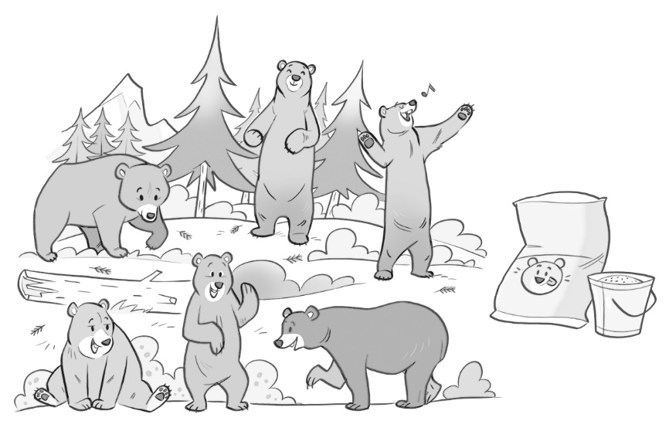

How Much Do They Eat? (cont’d)
Part A

Number
Unit 4 Line Master 3b

Problem 2
There are 5 elephants at a safari park.
Each day, they receive a 150-kg bag of food.
The food is shared equally among them.
