Distance Travelled

Number
Unit 2 Line Master 5

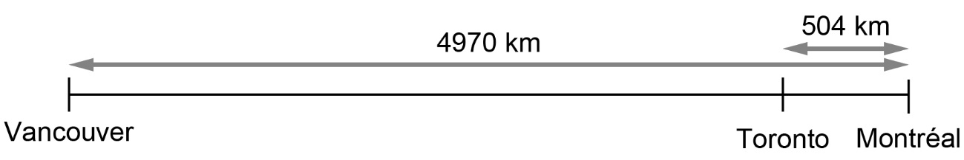

How far is it from Vancouver to Toronto?

