Analyzing and Classifying 2-D Shapes and Using Algebraic Thinking
Reads and alters code by testing out various values or blocks until desired outcome is attained.  “I’m going to change the steps to 50 and the wait to 2 and the degrees to 100.” | Reads and alters code by visualizing and explaining the impact of changes until desired outcome is achieved.  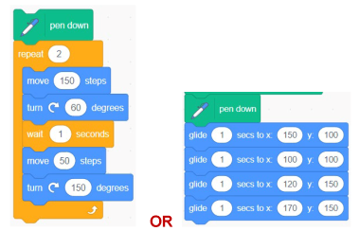  “I’ll change the steps to 50 and the degrees to 120, so they add to 180 and it’s a rhombus. I’ll delete the wait because it doesn’t impact  the end image.”  OR  “This is going to make a narrow parallelogram because I can visualize the vertices.” | Reads and flexibly alters code and makes sense of conditional statements related to outcomes of code when classifying shapes.  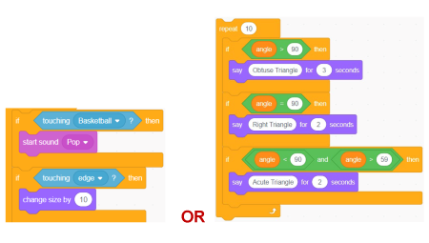  “I’m going to make the condition that if Balloon is touching Basketball, it ‘pops,’ but if it’s touching the edge, it gets bigger.” OR “I’ve created conditions for the 3 types of triangles based on the greatest angle, but now I still need to account for any other values like 0, 160, and 180 or more.”
Observations/Documentation

Analyzing and Classifying 2-D Shapes and Using Algebraic Thinking (cont’d)
Uses basic blocks to write code for a desired outcome.  “I tried using these blocks in this order, but it didn’t make what I wanted.” | Uses more complex blocks (including repeat and conditional statements) to write code for a desired outcome.  “I wrote code, but it used so many blocks. I can see that these blocks repeat. So, I used the repeat block instead and deleted these other blocks. I put it inside the ‘If, then’ because if it has 3 sides, it will draw this triangle.” | Uses conditional statement blocks to flexibly write different code related to outcomes and the classification of shapes.  “Writing code with conditional statements is like creating a flow chart. All the possibilities must be accounted for. If the condition isn’t met, then we need to have other options, with the ‘else’ block defining the other situations”
Observations/Documentation

