Solving and Graphing for Inequalities
Recognizes inequality symbols and their meanings in various inequality equations.  3m > 18  3m ≥ 18  “Each time, the unknown can be any number greater than 6. In the second equation, it could also be 6. There are many quantities that would work.” | Represents solutions by graphing on a number line and tests values to check solutions.  25 > 5m  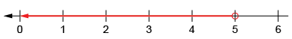  “The unknown multiplied by 5 must be less than 25. I can count by groups of 5 to get to 25. So, the unknown is 1, 2, 3, or 4.” | Verifies the solution by thinking of related equality and testing numbers.  3m ≥ 18  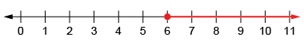  “I can use the number line to graph the solution. I know 3 × 6 = 18. So, the unknown can be any number equal to or greater than 6.” | Flexibly solves inequalities, then verifies and graphs the solutions.  5 > $\frac{n}{4}$  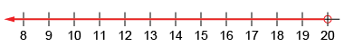  “What number can I divide by 4 so that the answer is less than 5?  I can rearrange the equation to find the unknown: 5 × 4 > n”
Observations/Documentation

