Solving for Unknowns in Equations
Uses ‘guess and check.’  3n = 72  “I know 3 times 20 is 60.  So, n must be more than 20.  3 × 30 = 90 (too high)  3 × 25 = 75 (too high, but close)  3 × 24 = 72  So, n = 24 because 3 × 24 =72.” | Uses the balance model.  3n = 72  72 ÷ 3 = n  or  27 + n = 45  45 − 27 = n  “I used a balance model. I moved the numbers and variable around until the equations were equivalent and I could find the solution.” | Uses relationships among operations (inverse operations, associative property).  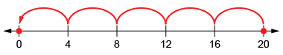  “I rewrote the equation as a division equation:  20 ÷ 4 = $∎$.”
Observations/Documentation

Solving for Unknowns in Equations (cont’d)
Uses a flow chart to solve by decomposing and recomposing numbers.  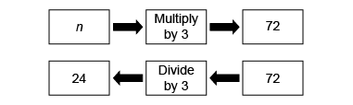  “I can decompose the equation into parts using the flow chart, then reverse the flow using the inverse operation to solve for the unknown.” | Interprets and writes a statement for a given equation and solves for the unknown.  n ÷ 5 = 8  “I collected a jar full of shells. I shared the shells with 5 of my friends. Each person got 8 shells. How many shells did I collect for my friends? | Flexibly uses multiple strategies to solve equations.  54 ÷ n − 6 = 3  “54 ÷ n = 3 + 6 so, 54 ÷ n = 9.  I then rearranged the equation:  n × 9 = 54, so n = 6 because 6 × 9 = 54.”
Observations/Documentation

