Number Pattern Relationships
Recognizes pattern relationships in  increasing patterns.  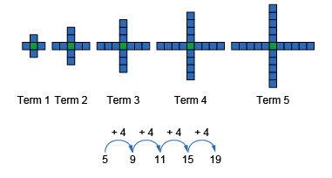  “I see a skip-counting by 4 forward relationship in the pattern. The rule is: Start with 5 tiles and add 4 tiles each time.” | Recognizes pattern relationships in  decreasing patterns.  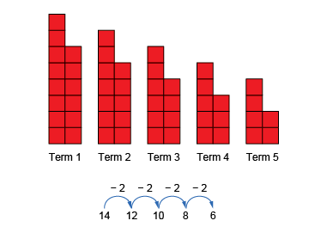  “I see a skip-counting by 2 backward relationship in the pattern. The rule is: Start with 14 tiles and take away 2 tiles each time.” | Identifies and describes pattern relationships in tables, charts, and diagrams.  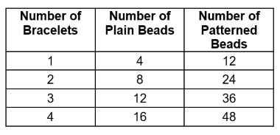  “The rule for the number of plain beads is:  Multiply the number of bracelets by 4: 4n.  I see number relationships:  1 × 4 = 4, 2 × 4 = 8, 3 × 4 = 12, 4 × 4 = 16.”
Observations/Documentation

Number Pattern Relationships (cont’d)
Identifies and describes pattern relationships on graphs.  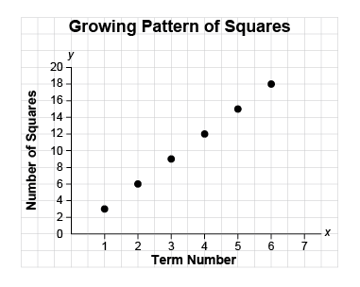  “The graph shows the pattern rule: Start  with 3 squares.  Multiply the term number by 3 each time.  The expression 3t describes  the pattern relationship.” | Describes patterns to illustrate the relationships among whole numbers and decimals with tenths and hundredths.  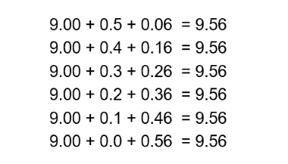  “I noticed a pattern: As the second addend decreases by 0.1, the third addend increases by 0.10, so the sum stays the same.” | Fluently identifies and describes different patterns in a variety of representations.  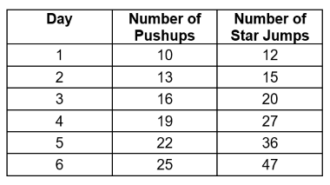  On which day will 40 pushups be completed?  “I wrote an expression for the pattern rule using multiplication: 3d + 7, where d is the day number.  I substituted values for d until I got  40: 3 × 11 + 7 = 40; Day 11.”
Observations/Documentation

