Conceptual Meaning of Whole Number Addition and Subtraction
Recognizes addition and subtraction situations and sketches a picture to  add or subtract to 10 000.  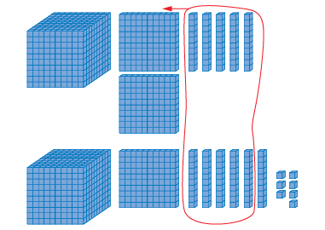  1250 + 1167 = 2417 | Models and symbolizes ways to solve problems to 10 000.  1250 + 1167 = 2417  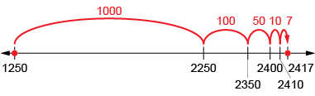 | Uses an understanding of place value to decompose both numbers to solve problems to 100 000.  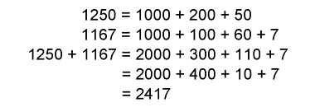  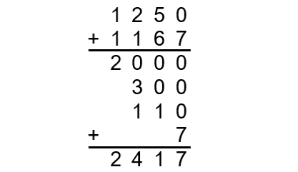  “I added the thousands, the hundreds, the tens, and then the ones.”
Observations/Documentation

Conceptual Meaning of Whole Number Addition and Subtraction (cont’d)
Uses an understanding of place value to decompose one number  to solve problems to 100 000.  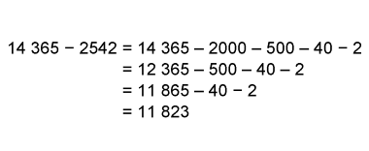 | Estimates to determine if answer to problem is reasonable.  14 365 – 2542 = 11 823  “I estimate 12 000 because  14 365 is close to 14 500,  2542 is close to 2500,  and 14 500 – 2500 = 12 000.  12 000 is close to 11 823,  so, my answer is reasonable.” | Creates and solves multi-step addition and subtraction problems flexibly using a variety of strategies.  8134 bottles were collected by the school. 4612 were donated by the community. 1645 were not accepted at the recycling depot. How many bottles were recycled?  “I added 8134 + 4612 = 12 746.  Then, 12 746 – 1645 = 11 101.  11 101 bottles were recycled.”
Observations/Documentation

Developing Fluency of Whole Number Addition and Subtraction
Uses known sums and differences to fluently solve addition and subtraction problems to 1000.  435 + 578 = ?  “I know 430 + 570 = 1000.  Since 435 is 5 more than 430 and 578 is 8 more than 570, and 8 + 5 = 13, the answer is 1013.” | Purposefully uses properties and/or relationships to solve addition and subtraction problems.  226 + 435 + 574 + 375 = ?  “I can rearrange the numbers  to make it easier to add.”  226 + 574 + 435 + 375 = ?  226 + 574 = 800  435 + 375 = 810  800 + 810 = 1610 | Understands the inverse relationship between addition and subtraction and uses it to solve problems.  1619 – 815 = ?  “I can think addition: 815 + ? = 1619.  I added on: 815 + 200 = 1015,  1015 + 600 = 1615,  1615 + 4 = 1619  The missing part is 200 + 600 + 4 = 804.”
Observations/Documentation

Developing Fluency of Whole Number Addition and Subtraction (cont’d)
Uses mental math strategies and algorithms (e.g. using benchmark numbers, known facts, partial sums).  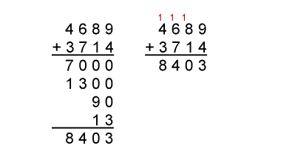  “I could used partial sums  or the standard algorithm.” | Uses estimation to check the reasonableness of solutions.  There are 648 French Immersion students. 174 more students plan to enroll in the Fall. The program can have 835 students. Is there enough space?  “648 is close to 650 and 174 is close to 175.  650 + 175 = 825. 835 – 825 = 10;  about 10 spaces.  I overestimated because we want to make sure we have enough spaces for the students.” | Flexibly creates and solves multi-operational problems and checks reasonableness of solutions.  7350 – 326 = ?  7350 – 300 = 7050  7050 – 26 = 7024 books in library.  7050 is close to 7024, so the solution is reasonable.
Observations/Documentation

