Applying and Visualizing Translations and Reflections
Identifies translations and reflections of 2-D shapes on a grid.  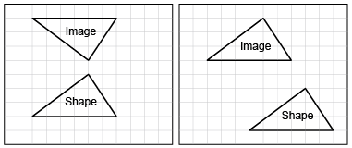  “The first image shows a reflection and the second image shows  a translation.” | Identifies the translation/reflection used to move a shape and line of reflection.  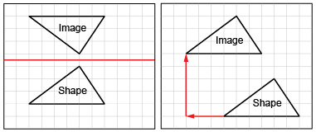  “The first shape was reflected in a horizontal line midway between the shape and its image. The second shape was translated left 3 squares and up 5 squares.” | Describes and performs translations and reflections on a grid using labelled vertices.  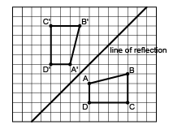  “I labelled matching vertices with the same letter. The vertices of the image have prime symbols.” | Visualizes and predicts where image of a shape will be after a translation/reflection.  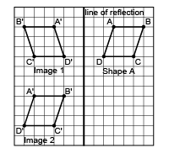  “I can picture Shape A’s reflection Image 1 on the other side of the line, with matching vertices the same distance from the line of reflection. I can picture moving Shape A left 8 squares and down 7 squares  to Image 2.”
Observations/Documentation

Applying and Visualizing Rotations on a Grid
Identifies rotated 2-D shapes  on a grid.  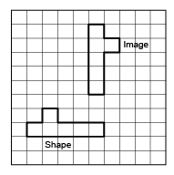  “I know the shape was rotated because the shape and its image are congruent, but the orientation  is different.” | Identifies the rotation used to move a shape and the point of rotation.  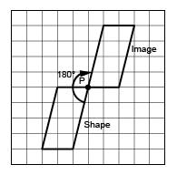  “The shape was rotated 180° about the common vertex P.” | Describes and performs rotations with angles up to 180°.  “I used tracing paper to rotate the shape 90° counterclockwise about Point Q. I labelled matching vertices with the same letter.  The vertices of the image have prime symbols.” | Visualizes, predicts, and describes where the image of a shape will be after a rotation.  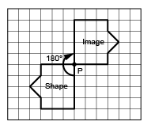  “I can picture rotating the shape in my mind. The image would face the opposite way and share Vertex P with the shape.”
Observations/Documentation

