Locating and Plotting Points in First Quadrant of Cartesian Plane
Uses coordinates to describe the location of points on a grid.  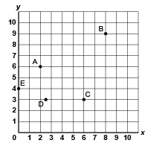  “The coordinates of Point A are  (2, 6).” | Plots and identifies points with decimal coordinates on a grid with various scales.  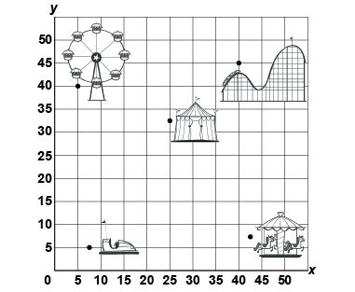  “The bumper cars are at (7.5, 5).” | Translates a point and identifies coordinates of its image.  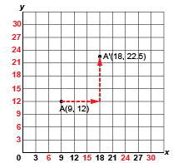  “I translated Point A right 9 units and up 10.5 units to A’(18, 22.5).” | Flexibly predicts the location and coordinates of a point after  a translation.  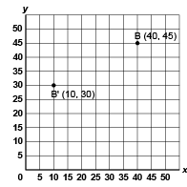  “The translation was left 30 units and down 15 units. So, I subtracted 30 from the x-coordinate and 15 from the y-coordinate:  (40 – 30, 45 – 15) B’(10, 30).”
Observations/Documentation

