Drawing Views
Recognizes that views of a 3-D object will vary according to the orientation.  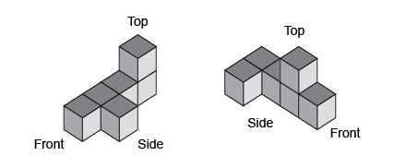  “When you change the orientation of the object, you change the views.” | Understands that 3-D objects can be represented in two dimensions with different views.  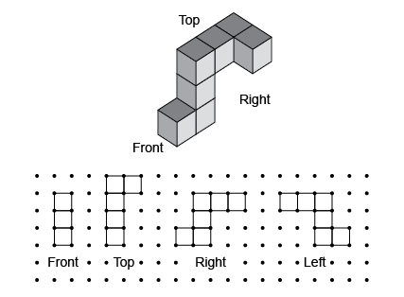  “I looked at the object from each view to find the matching drawing of that view.” | Draws top, front, and side views of objects and matches views to  3-D object.  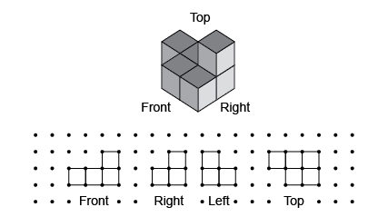  “I used square dot paper to draw and label each view of the object.” | Builds 3-D objects using given views, then changes the orientation and draws new views.  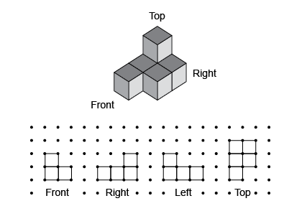  “I visualized the object by looking at each view and then built it. When I change the orientation of the object, the perspective changes the views.”
Observations/Documentation

