Describes and Constructs Regular and Triangular Prisms
Recognizes and names common attributes of rectangular and triangular prisms.  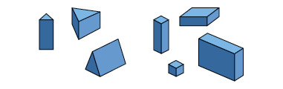  “Triangular prisms have some faces that are triangles. Rectangular prisms have faces that are rectangles.” | Describes attributes of rectangular and triangular prisms.  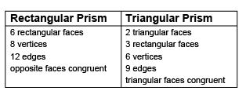 | Sorts a set of rectangular and triangular prisms using the shape of the base.  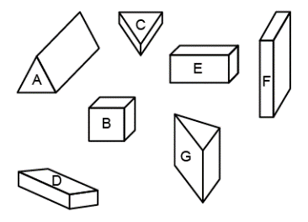  “When the shape of the base is a triangle, it’s a triangular prism.”
Observations/Documentation

Describes and Constructs Regular and Triangular Prisms (cont’d)
Constructs and describes models of rectangular and triangular prisms using various materials.  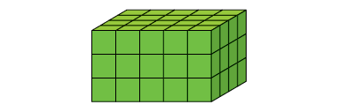  “I made a rectangular prism using linking cubes. All the faces are rectangles and there are 8 vertices.” | Constructs rectangular and triangular prisms from their nets.  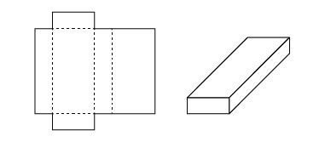  “I knew this would make a rectangular prism because there are 3 pairs of congruent rectangles and when I visualized folding the net, they were opposite each other.” | Makes and applies generalizations about rectangular and triangular prisms to objects in the environment.  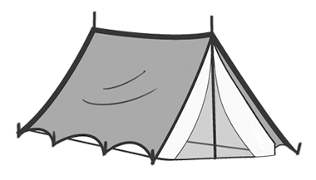  “A tent shaped like a triangular prism only needs one pole in the centre to support it and there is easy access through the triangular-faced door. The rectangular faces make it sturdy.”
Observations/Documentation

