Interpreting Double-Bar Graphs
Draws conclusions based on  data presented.  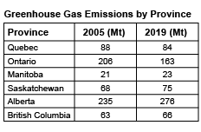  “Only Quebec and Ontario reduced their greenhouse gas emissions from 2005 to 2019. Alberta had the greatest increase and Manitoba had the smallest increase.” | Uses inferences to make predictions about future events.  “Ontario has a large manufacturing industry and Alberta has a large oil and gas industry. It might help Alberta to talk to Ontario about ways to reduce emissions to help slow global warming.” | Interprets the results of data presented graphically.  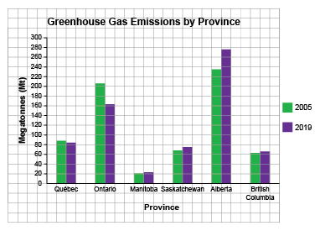  “Ontario reduced its emissions by about one-fifth because the lengths of the bars are about 10 squares and 8 squares.” | Analyzes 2 sets of data to make convincing arguments and informed decisions.  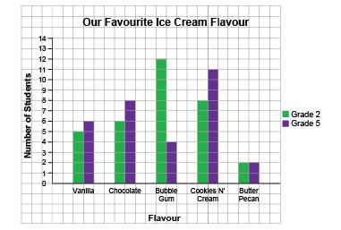  “I noticed that Bubble Gum and Cookies N’ Cream are the favourites for both classes. To sell more ice cream, the ice cream truck driver should have more of these flavours and less of Butter Pecan because it was the least favourite  in both grades.”
Observations/Documentation

