Patterning and Algebra
Unit 3 Line Master 5a
Coding a Shape Design
Using a Block-Coding Program

Part 1: Coding a Shape Design using Nested Events
Look at the code.
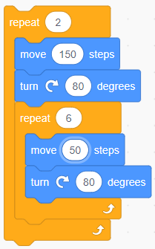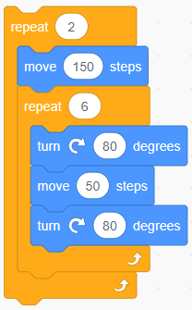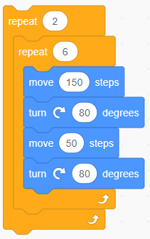

Notice there are 6 repeats within the repeat of 2 in each case.
The repeat of 2, without any repeats inside, would make
the design shown.
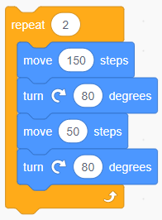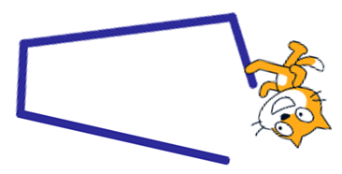
Patterning and Algebra
Unit 3 Line Master 5b
Coding a Shape Design (cont’d)
Using a Block-Coding Program

In each of the coding examples provided with a repeat of 6 inside,
parts or all of the repeat of 2 will be repeated 6 times.
Where the repeat of 6 is placed will change the outcome significantly.

Predict what design each of the code sequences will create.
Try to visualize the movements in your mind. In fact, you can “walk”
them out physically or in your mind, or sketch them on paper.
Don’t worry if you’re not sure — try to make a prediction anyway!
These are the outcomes for each code sequence.
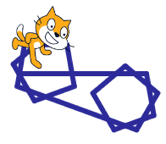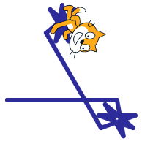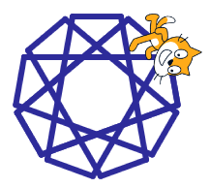

Patterning and Algebra
Unit 3 Line Master 5c
Coding a Shape Design (cont’d)
Using a Block-Coding Program

Work in the file and execute these code sequences.
Here’s the link to the code for you to try out: https://scratch.mit.edu/projects/550619357/
Click See Inside to access the code.
Click the individual green flags to execute the code for each script,
rather than the flag at the top right.
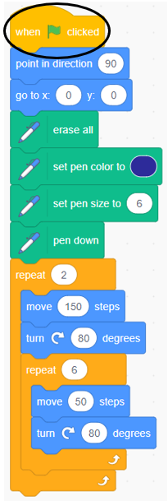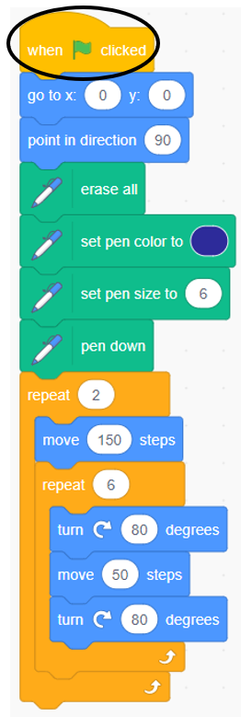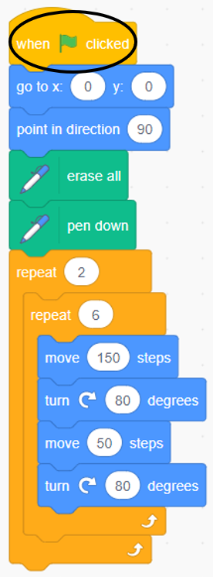
Add wait times to help you see what each block of code does.
Were any of your predictions correct?
Patterning and Algebra
Unit 3 Line Master 5d
Coding a Shape Design (cont’d)
Using a Block-Coding Program

Mind-Sized Bites
Seymour Papert is a famous mathematician. He created Logo, the first programming language for kids upon which Scratch is based.
He also spoke of “mind-sized bites”. When visualizing what happens
in these code blocks, be conscious of the separate chunks.
Look at each enclosed repeat container as a chunk and
make sense of it. This idea of decomposition is one of the skills of
computational thinking.
One way to direct Cat is to tell Cat to move to a specific spot.
For example:
tells Cat to go to (0,50) on the Cartesian plane.
tells Cat to go to (0,0) on the Cartesian plane.
tells Cat to go to (50,0) on the Cartesian plane.

Try it out! Start your own code or click the link below to try it out:
https://scratch.mit.edu/projects/550920160/

The different values for the x and y coordinates will move Cat to
other parts on the screen, but you won’t have to worry about
changing these values in the upcoming activity.

What do you think this code will create? Why?
Patterning and Algebra
Unit 3 Line Master 5e
Coding a Shape Design (cont’d)
Using a Block-Coding Program

Recreate this application or click the link below and execute the code
to check:
https://scratch.mit.edu/projects/550919596/

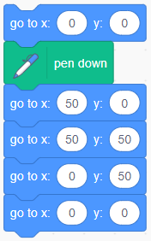

Patterning and Algebra
Unit 3 Line Master 5f
Coding a Shape Design (cont’d)
Using a Block-Coding Program

Part 2: Coding a Shape Design with Concurrent Events
Fish and Butterfly are playing together.
Fish is swimming in a pattern under the water.
Butterfly is trying to match Fish’s movements.
But Butterfly is also making a pattern above the water,
and Fish is trying to match Butterfly’s movements.

Let’s execute the code and see what happens.
Click this link to access the file:
https://scratch.mit.edu/projects/550920489/
Execute the code by clicking the green flag on the preview page.

What do you notice? What do you wonder?

How do you think the code sequences are alike?

How do you think they are different?

Click See Inside to access the code.
Notice the nested loops. Here are the outcomes:

Patterning and Algebra
Unit 3 Line Master 5g
Coding a Shape Design (cont’d)
Using a Block-Coding Program

Part 3: Challenge
Work with your partner.
Alter the code so that Fish creates Butterfly’s flying pattern
(but without looking at the code and copying it exactly).
OR
Alter the code so that Butterfly creates Fish’s swimming pattern
(again without looking at the code and copying it exactly).
As you test out different code sequences, predict how your changes
will impact the outcome. Talk about what you’re changing and why. Change 1 thing at a time!

As you try to recreate the pattern, you might get stuck frequently or
have to start again. Don’t worry! This is common when we are coding.
When you have the exact same patterns, make sure that you make
the movements at the same time (like you are playing a mirror game).

Patterning and Algebra
Unit 3 Line Master 5h
Coding a Shape Design (cont’d)
Using a Block-Coding Program

Tips
Wait time is included in this code.
This impacts the movement—the speed the program executes,
but not the final outcome.
The code sequences for each sprite are kept separately.
To access one, click the icon for the corresponding sprite.
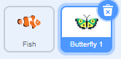
If you want to alter the sprite in any way, click the Costumes tab
at the top.
The line was created by adding a Backdrop.

Patterning and Algebra
Unit 3 Line Master 5i
Coding a Shape Design (cont’d)
Using a Block-Coding Program

Self-check in
What have you learned about block coding so far?
Did you get stuck? If so, what did you do?
Did you turn to your classmates for help? If so, how did they help?
What are you doing to help the learning of others?
This is “hard fun.” What do you think we mean by “hard fun”?
What other activities do you do that are “hard fun”?

