Patterning and Algebra
Unit 3 Line Master 4a
Making Shapes
Using a Block-Coding Program

Which of the images below did each set of block code create?
How do you know?
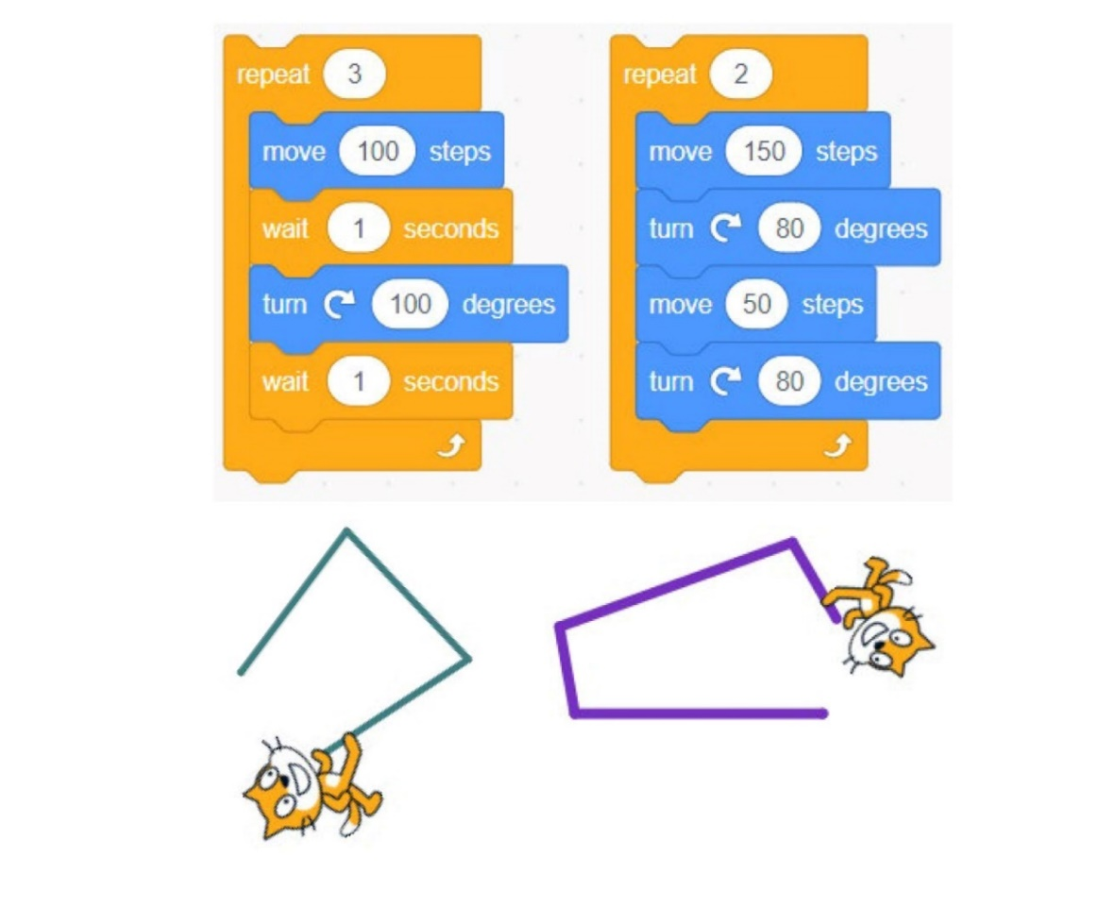
How are the code sequences alike? How are they different?
What do you think move, turn, repeat, and point in direction might mean?
Notice the colour coding that is used to organize blocks according to function: blue indicates Motion blocks; orange indicates Control blocks, and dark green indicates Pen. Note that the code above is missing some important blocks for the sprite to draw the shapes.

Patterning and Algebra
Unit 3 Line Master 4b
Making Shapes (cont’d)
Using a Block-Coding Program

In the program you looked at as a class, a character called a “sprite”
(in this case, Cat) is trying to draw a rectangle and a square.
You are going to investigate how you might edit the “code” to help
Cat walk over these shapes.
Be sure to add the Pen Extensions before you begin.
Go to: http://scratch.mit.edu  Log in, if your teacher would like  you to.  Click Create to add a new project  and name it.  Click the Add Extension icon  at the bottom left.  Click the Pen. Draw with your  sprites icon.  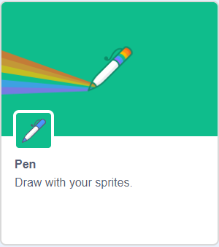 | 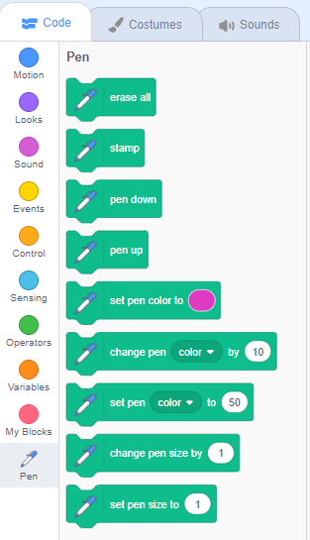
You will now see extra blocks for drawing with the pen.
Patterning and Algebra
Unit 3 Line Master 4c
Making Shapes (cont’d)
Using a Block-Coding Program

You will see the same code again.
This time they have the necessary pen commands.
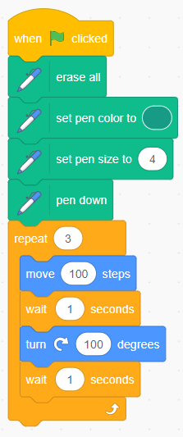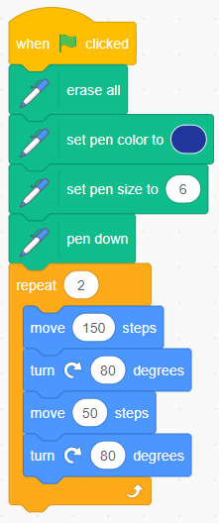

Why do you think all of the beginning code is important?
What does each block do?

Patterning and Algebra
Unit 3 Line Master 4d
Making Shapes (cont’d)
Using a Block-Coding Program

You may want to add the following motion blocks to ensure that
the sprite will begin in the right direction and at the centre of
the stage each time.

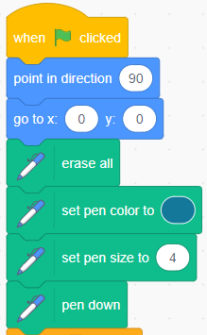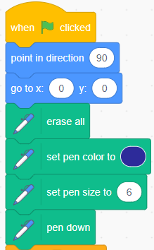

Patterning and Algebra
Unit 3 Line Master 4e
Making Shapes (cont’d)
Using a Block-Coding Program

Challenge A: Code Cat to draw a square.
Work with your partner.
Start with a blank project or modify the project provided.
1. Use a blank project page to make your own.
● Create a new project (if necessary).
● Add in the Pen Extensions (as above), if you haven’t already.
● Use the above code image to find the blocks you will need.
OR
2. Modify this existing project: https://scratch.mit.edu/projects/479303643/
● Click See Inside to alter the code
or, if you’ve logged into Scratch, click Remix to get
your own copy of this project,
.
● Change some of the numbers, then see how your changes
impact the outcome (what Cat draws).
● Talk about what you’re changing and why.
Change just one thing at a time!
● You can always go back to the original link and start again.
Patterning and Algebra
Unit 3 Line Master 4f
Making Shapes (cont’d)
Using a Block-Coding Program

Challenge B: Code Cat to draw a rectangle.
Work with your partner.
Start with a blank project or go to the link provided.
1. Use a blank project page to make your own.
● Create a new project (if necessary).
● Add in the Pen Extensions (as above), if you haven't already.
● Use the above code image to find the blocks you will need.
OR
2. Modify this existing project: https://scratch.mit.edu/projects/550915078/
● Click See Inside to alter the code
or click Remix to get your own copy of this project.
● Change some of the numbers, then see how your changes
impact the outcome (what Cat draws).
● Talk about what you’re changing and why.
Change just one thing at a time!

Patterning and Algebra
Unit 3 Line Master 4g
Making Shapes (cont’d)
Using a Block-Coding Program

Self-check in
What have you learned about block coding so far?
Did you get stuck? If so, what did you do?
Did you turn to your classmates for help? If so, how did they help?
What are you doing to help the learning of others?
This is “hard fun.” What do you think we mean by “hard fun”?
What other activities do you do that are “hard fun”?

