Patterning and Algebra
Unit 3 Line Master 2a
Coding on a Grid

How could you write code to move the dog to the owner? The owner to the dog?
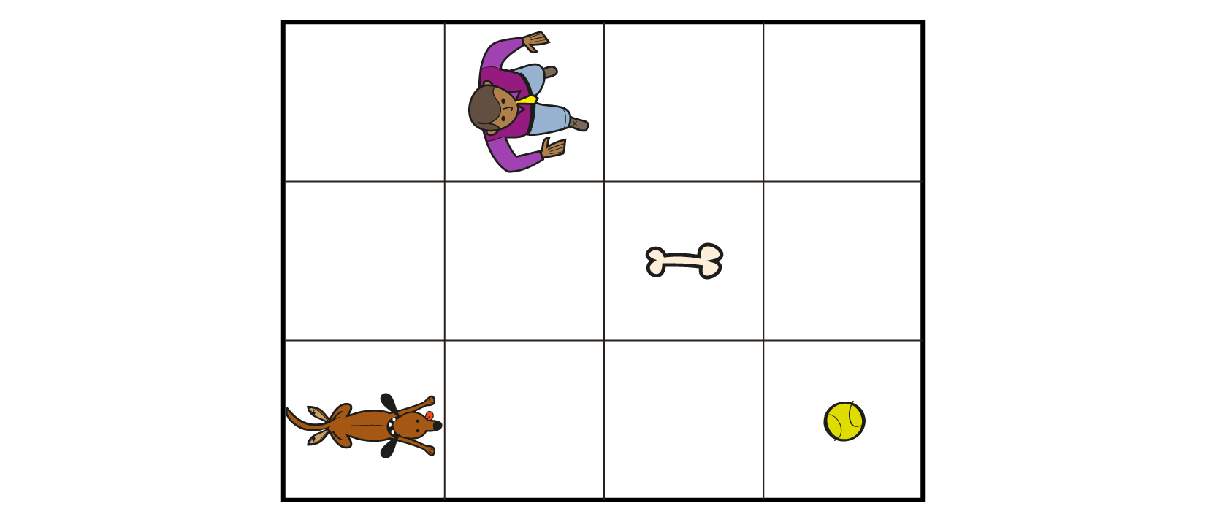
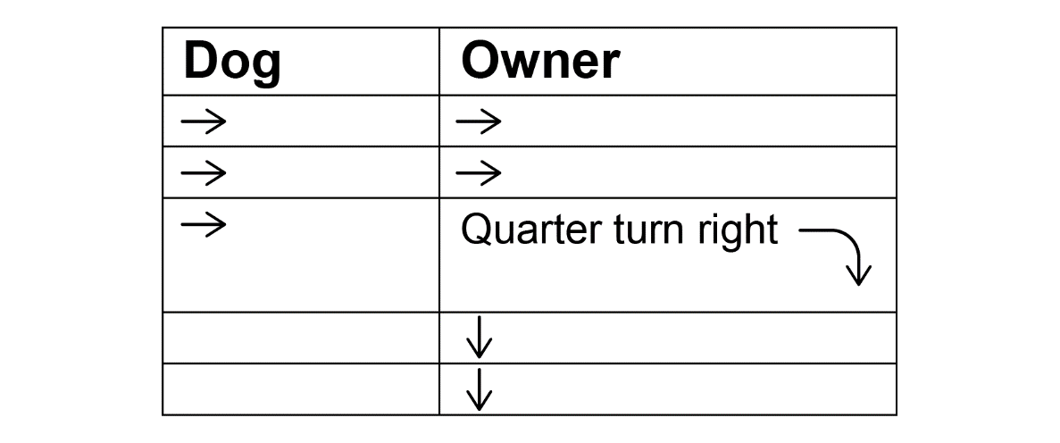
We can use code with arrows and numbers. For example, to write code to move the dog to the ball, we can write →→→ or 3→.
We use concurrent code when events are happening at the same time (e.g., the dog and owner running to the ball at the same time).
For example:
Patterning and Algebra
Unit 3 Line Master 2b
Coding on a Grid (cont’d)

Notice the difference between a turn arrow (e.g., to show a quarter or half-turn) and a square bracket used to show a repeat (e.g., going back to a previous step in the process and repeating).

A repeat arrow could be used if the dog was playing fetch and the owner kept throwing the ball to the same location on the grid.
For example: Dog

Do Part B of the activity.

Patterning and Algebra
Unit 3 Line Master 2c
Coding on a Grid (cont’d)
Part A

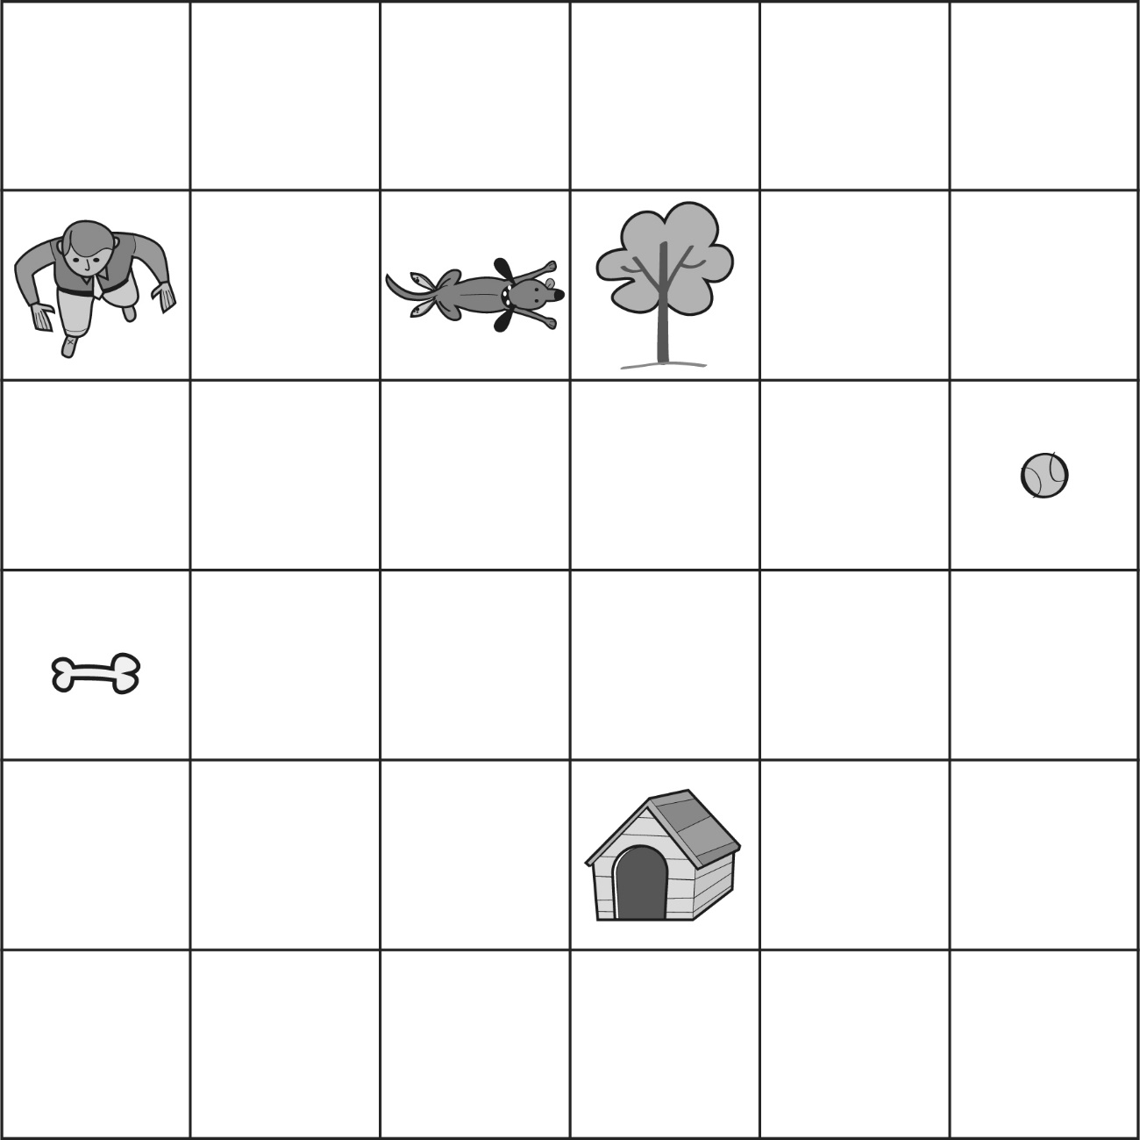

Patterning and Algebra
Unit 3 Line Master 2d
Coding on a Grid (cont’d)
Tasks

Here are 2 different ways to write the coding instructions to get
the same result.
● 1 down, 1 right, 1 down, 3 right, 1 down, 1 right, 2 up
● 1 step forward, $\frac{1}{4}$ turn left, 1 step forward, $\frac{1}{4}$ turn right,
1 step forward, $\frac{1}{4}$ turn left, 3 steps forward, $\frac{1}{4}$ turn right,
1 step forward, $\frac{1}{4}$ turn left, 1 step forward, $\frac{1}{4}$ turn left,
2 steps forward

Which way do you prefer? Why? Why might you need to use both ways?

What is a simpler way to write the same code?

These code sequences move which object to where?
How did you find out?

Patterning and Algebra
Unit 3 Line Master 2e
Coding on a Grid (cont’d)
Tasks

Write a code that:
Moves the dog to the bone.

Moves the dog to the bone with 8 “steps.”

Moves the dog to the back of the doghouse.

How could you adjust the code so the dog gets to the front door?

Moves the dog to the right side of its owner.

Patterning and Algebra
Unit 3 Line Master 2f
Coding on a Grid (cont’d)
Tasks

Write a code that:
Has the dog running away from its owner.

Has the owner throwing the ball and the dog fetching it (remember to
include wait times if or when the dog or owner are not moving).
Dog | Owner

Has the dog running in a rectangle around the yard 3 times
(try to include a “repeat” around some code).

Patterning and Algebra
Unit 3 Line Master 2g
Coding on a Grid (cont’d)
Tasks

Place these objects on the grid in squares of your choice.
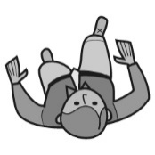 | 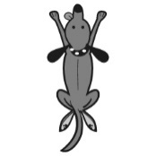 |  | 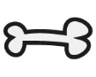 |  | 