Patterning and Algebra
Unit 3 Line Master 1a
Coding Routines

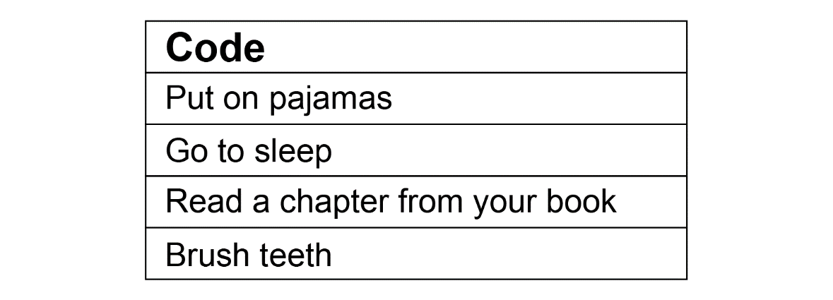
What is this code sequence for?

If this code was for your bedtime routine, would it be
in the correct order?

How might you reorganize the steps in the code so that
it is accurate?
Is more than one sequence possible? Explain.

Do Part A of the activity.
Use the coding templates on the next page.
Patterning and Algebra
Unit 3 Line Master 1b
Coding Routines (cont’d)

Code: Washing your hands

Code:

