Patterning and Algebra
Unit 2 Line Master 8a
Consolidation Chart
Equalities

Representation

Statement

Equation 1 | Equation 2 (inverse operation)
Solution | Verify Solution
Story Problem

Patterning and Algebra
Unit 2 Line Master 8b
Consolidation Chart
Inequalities

Statement

Inequality

Solution

Graph
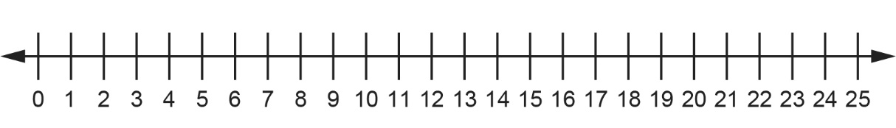
Verify Solution

