**Patterning and Algebra**

**Unit 1 Line Master 2a**

Other Venn Diagrams

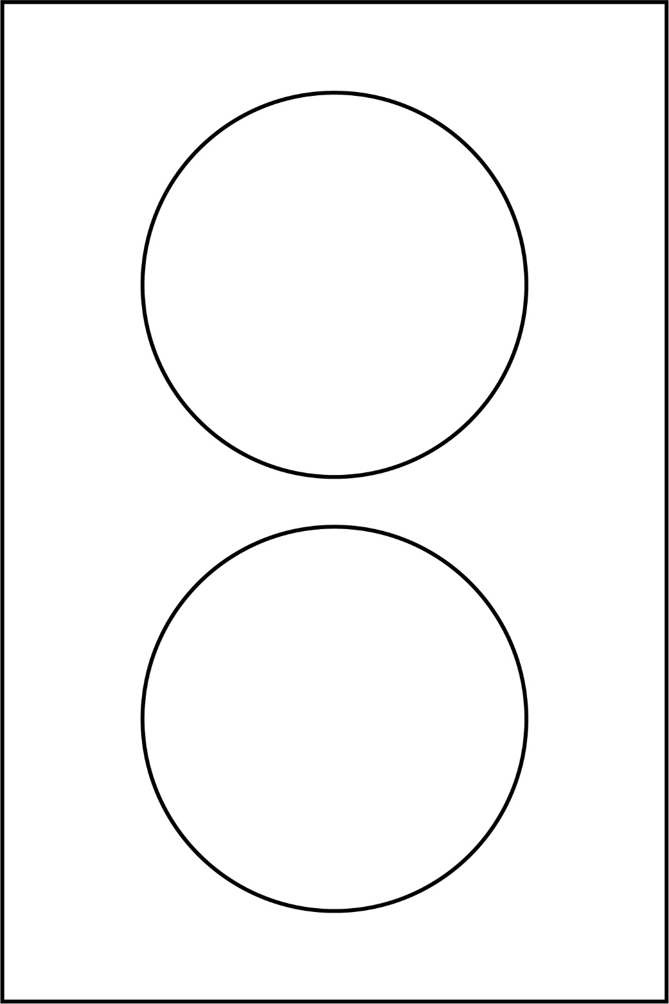

**Patterning and Algebra**

**Unit 1 Line Master 2b**

Other Venn Diagrams (cont’d)

