Can I Buy It?
Gameboard (Decimal Amounts)

Number
Unit 8 Line Master 4a

Raked  leaves:  earned $10 | Bought  supplies for  class pet:  $15.60 | Replaced  lost book:  $9.78 | Recycled  cans and  bottles:  $11.80 | Earned $25  delivering  newspapers
Paid library  fine:  $4.90 |  |  | 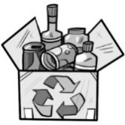 | Traded video  game:  received  $12.35
Garage sale:  earned  $27.80 |  |  |  | Donated to  animal  shelter:  $12.75
Your choice:  1 loaf of bread  for $2.25  3 loaves of  bread for $5.75 | 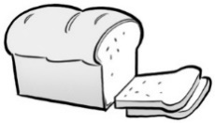 |  |  | Bought  present to  cheer up  sick student:  $18.66
Bought used  sled to  deliver  newspapers:  $10.50 |  |  |  | Won $20  in a raffle
START | Volunteered  at seniors’  home:  $0 | Received  gift card:  $14.60 | Bought  classroom  supplies:  $12.38 | Cleaned out  garage:  earned $10

Can I Buy It? (cont’d)
Gameboard (Whole-Dollar Amounts)

Number
Unit 8 Line Master 4b

Bought movie tickets:  $16 | Raked leaves:  earned  $10 | Shovelled  snow:  earned  $25 | Recycled cans and bottles: $12 | Paid  library fine:  $5
Volunteered  at seniors’  home:  $0 |  |  | 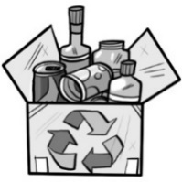 | Received  gift card:  $15
Your choice:  1 loaf of  bread for $2  5 loaves of  bread for $8 | 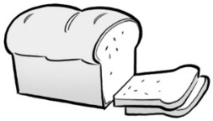 |  |  | Replaced  lost book:  $10
Bought  used sled:  $10 |  |  |  | Traded  video game:  received  $12
Cleaned out  garage:  earned  $13 |  |  |  | Bought  classroom  supplies:  $14
START | Bought present  for sick  student:  $19 | Donated to  food bank:  $13 | Garage sale:  earned  $28 | Won $25  in a raffle

