Reusable Treasures

Number
Unit 8 Line Master 2a

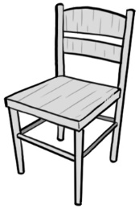 | 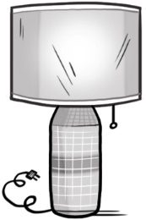 | 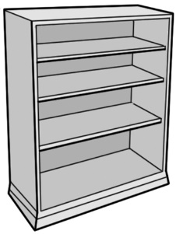
Chair  $27.25 | Lamp  $18.75 | Bookshelf  $35.35
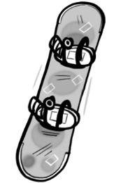 |  | 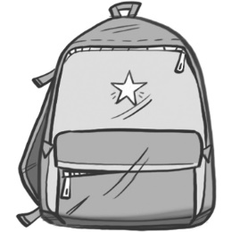
Snowboard  $59.95 | Video game  $12.30 | Backpack  $18.99
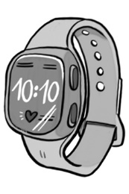 | 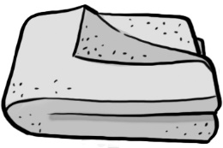 | 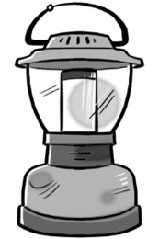
Watch  $36.90 | Blanket  $28.80 | Lantern  $19.40
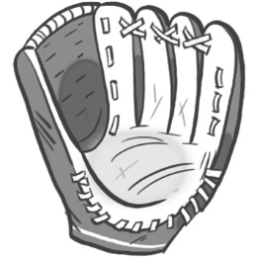 | 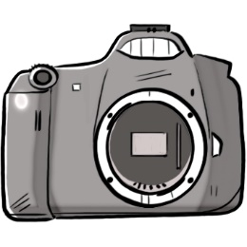 | 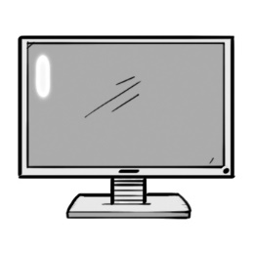
Baseball glove  $26.50 | Camera  $40.15 | Computer monitor  $29.95
Reusable Treasures (cont’d)
Recording Sheet

Number
Unit 8 Line Master 2b

You have $100 to buy 3 items from the thrift store.
Choose 3 items.
Justify your choice.

Estimate the total cost of the 3 items.

Calculate the total cost of the 3 items.
Show your thinking.

How much change will you get from $100?
Show your work.

Buy as many items as you like, to spend
as close to $100 without going over.

