Sports Equipment

Number
Unit 8 Line Master 1a

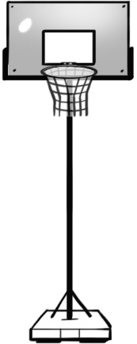 | 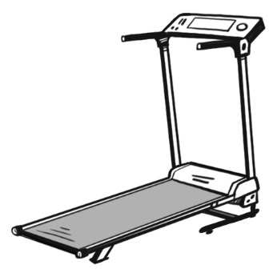 | 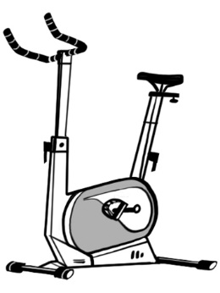
Basketball hoop  $387 | Treadmill  $465 | Exercise bike  $349
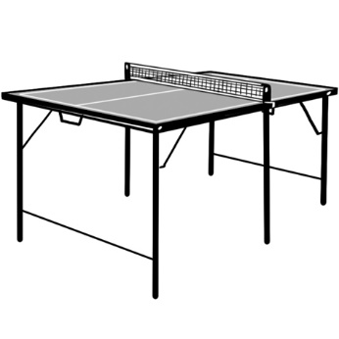 |  | 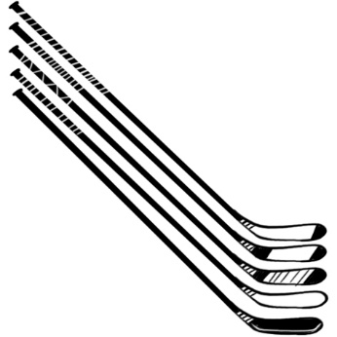
Ping pong table  $251 | Volleyball net  $65 | Hockey sticks  $199
 | 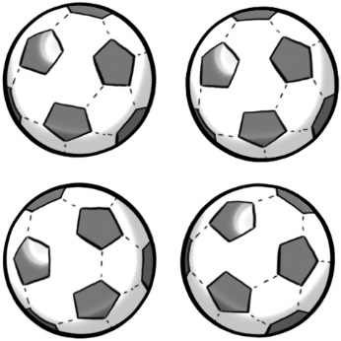
Soccer balls
$99

Sports Equipment (cont’d)
Recording Sheet

Number
Unit 8 Line Master 1b

Your school has been given a grant of $1000 to buy gym equipment for the community center.
Choose 3 pieces of equipment.

Estimate the total cost of the 3 pieces of equipment.

Explain how estimating the cost helped you decide what to buy.

Calculate the total cost of the 3 pieces of equipment.
Show your thinking.

How much money is left over?
Show the strategies you used.

Choose as many pieces of equipment as you want,
trying to spend as close to $1000 as you can without going over.

