Walking Trails
Number
Unit 5 Line Master 3a

Problem A
Two students walked the Wilderness Trail.  Charlie walks at a moderate rate.  Suki walks at a fast rate.  How long did it take each student to walk  the trail? | 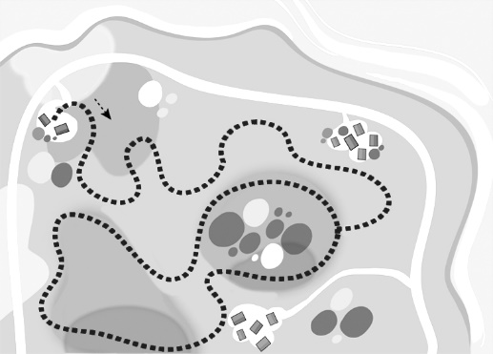
 | Wilderness trail: 7 km

Charlie
Distance (km) | 1 | 2 | 3 | 4 | 5 | 6 | 7
Time (min) | 10

Suki
Distance (km) | 1 | 2 | 3 | 4 | 5 | 6 | 7
Time (min) | 8

Walking Trails (cont’d)
Number
Unit 5 Line Master 3b

Problem B
Sofia walked the Nature Trail in 32 minutes.  At what rate did Sofia walk?  Distance (km) 1 2 3 4  Time (min) 32 | 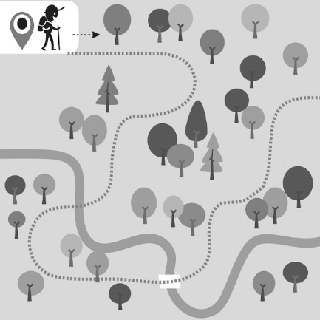
 | Nature trail: 4 km

Problem C
Kavana walked for 30 minutes at a moderate rate.
How far did Kavana walk?
Distance (km) | 1
Time (min) | 10 |  | 30

