Number
Unit 1 Line Master 1a
Place-Value Chart

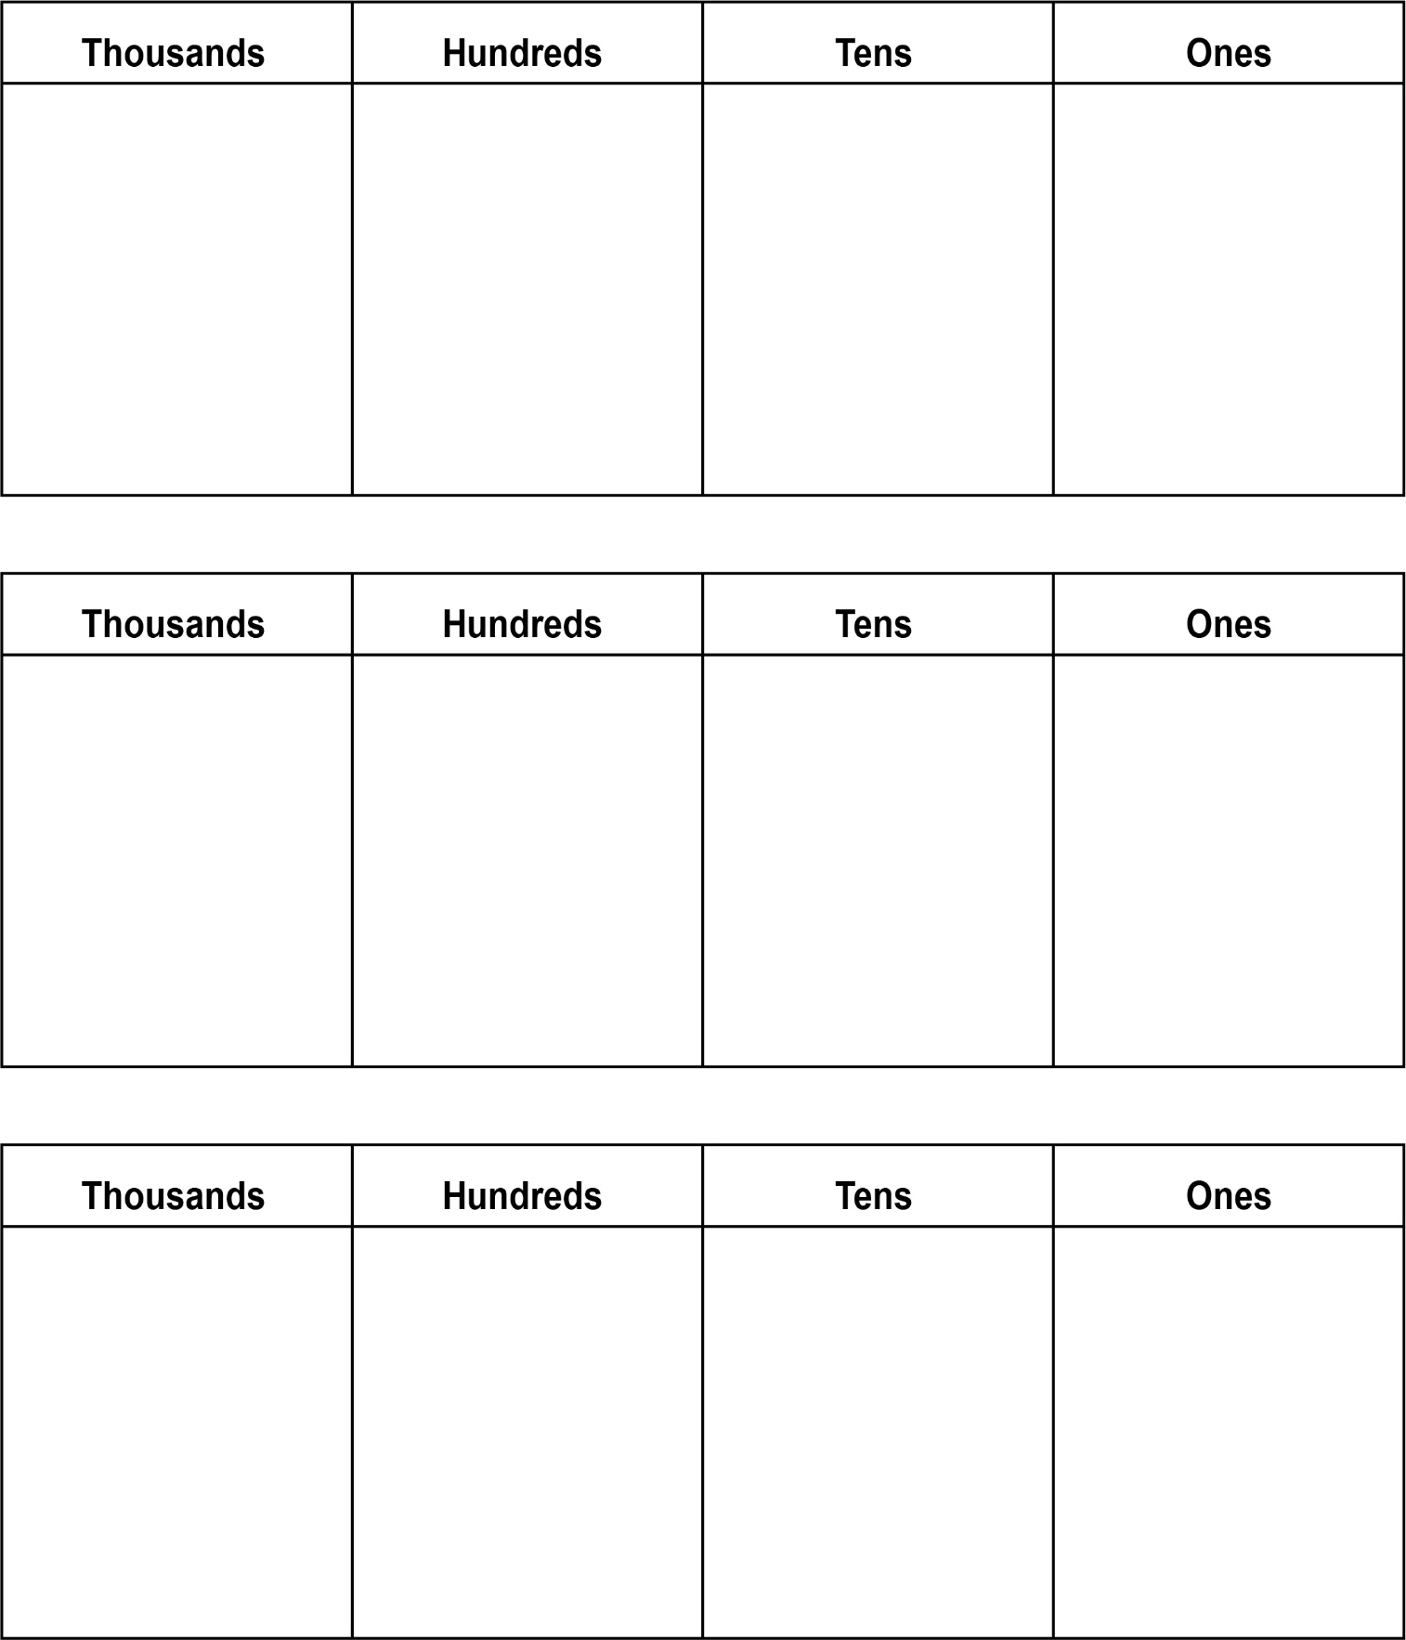
Number
Unit 1 Line Master 1b
Place-Value Chart (cont’d)

Ten Thousands | Thousands | Hundreds | Tens | Ones
Ten Thousands | Thousands | Hundreds | Tens | Ones
Ten Thousands | Thousands | Hundreds | Tens | Ones

