Measurement
Unit 3 Line Master 5
Schedule My Day

Use the 24-hour clock to make  a schedule for one day.  Include at least 3 morning activities,  3 afternoon activities, and 3  evening activities. | 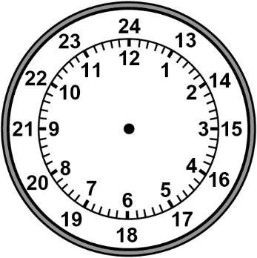

24-hour time | 12-hour time | Activity

