Measurement
Unit 3 Line Master 4a
Time Task B

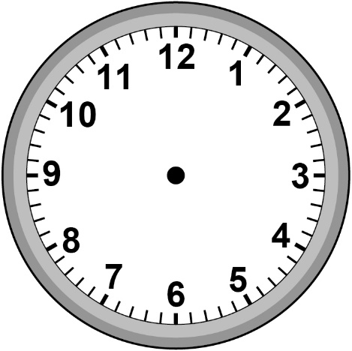
Five past three | Four thirty-six | Twelve thirty
Eight minutes to two | Seven fifteen | Twenty-five to four

Measurement
Unit 3 Line Master 4b
Time Task B (cont’d)

Digital Clocks

