**Geometry**

**Unit 2 Line Master 3a**

Transformation Designs

**Design 1**

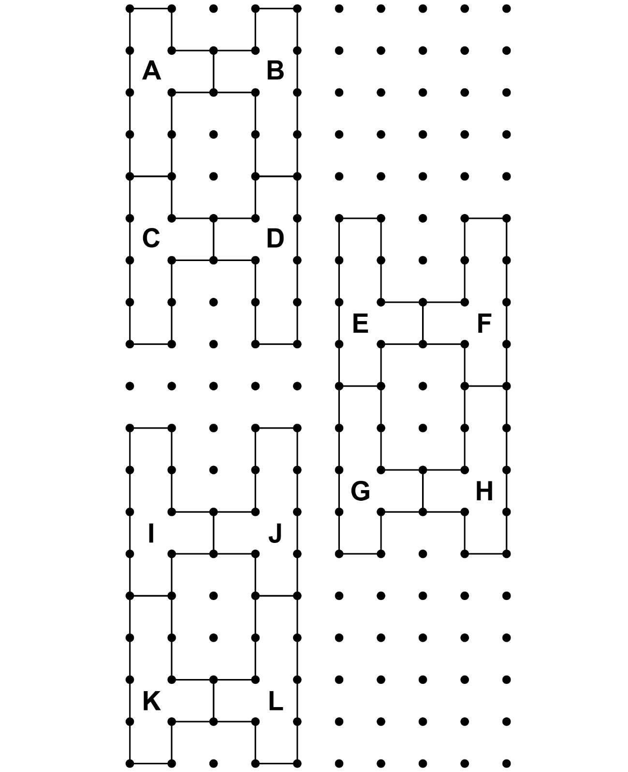

**Geometry**

**Unit 2 Line Master 3b**

Transformation Designs (cont’d)

**Design 2**

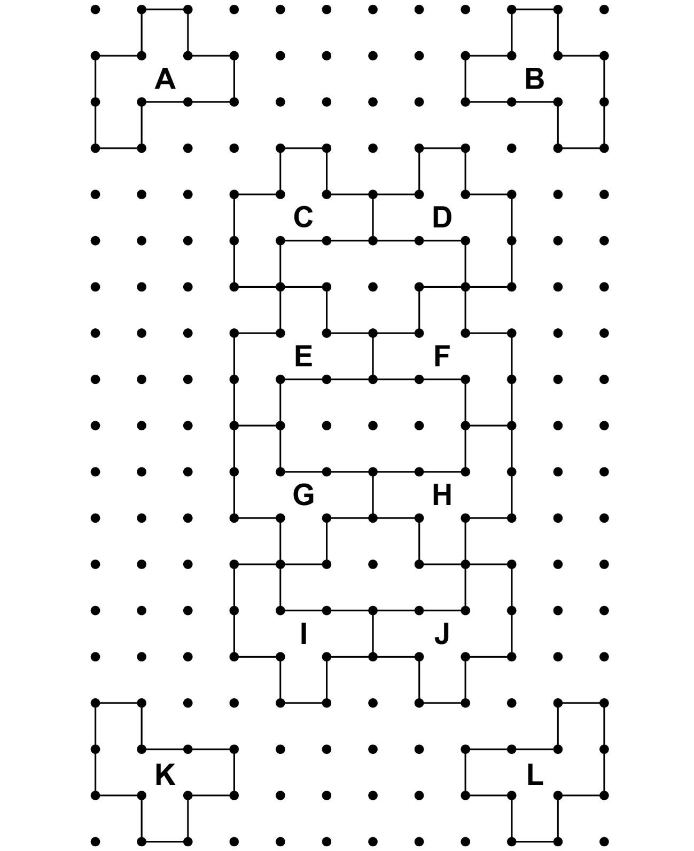

**Geometry**

**Unit 2 Line Master 3c**

Transformation Designs (cont’d)

**Design 3**

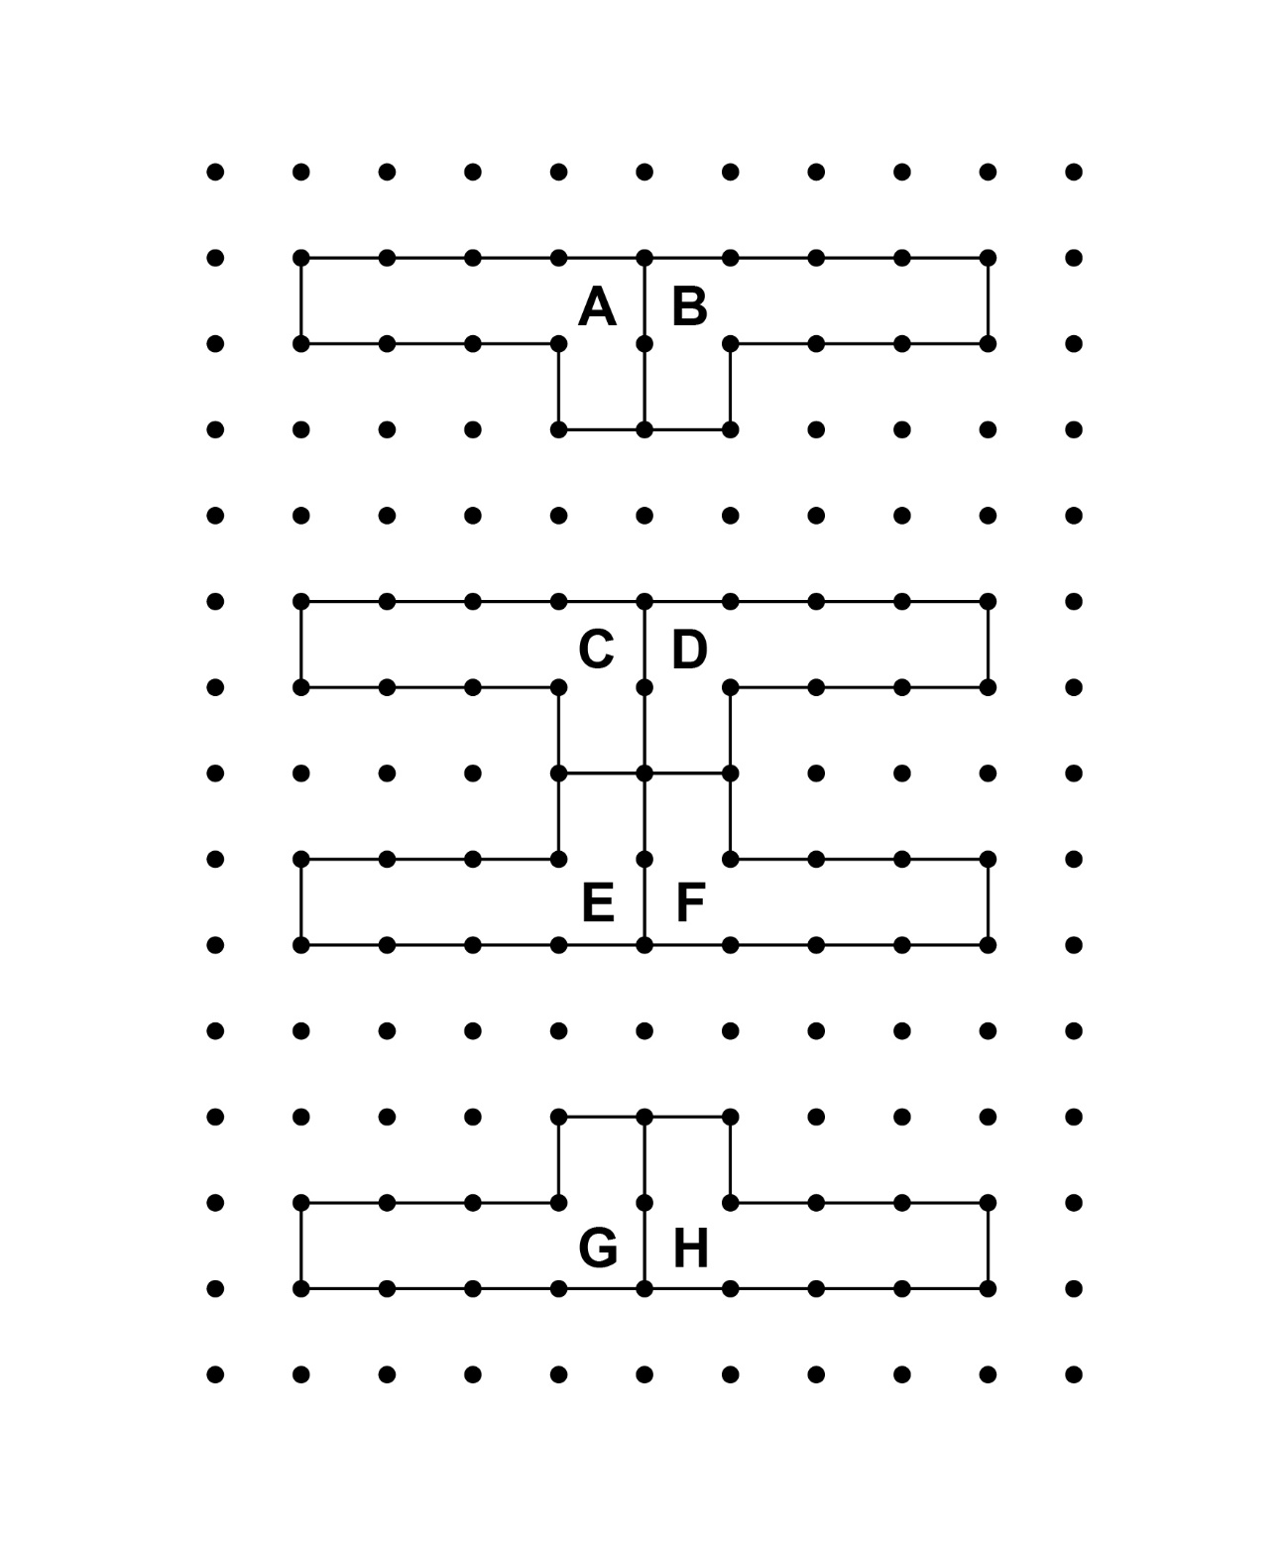

**Geometry**

**Unit 2 Line Master 3d**

Transformation Designs (cont’d)

**Design 4**

