Number Cubes

**Data Management**

**Unit 2 Line Master 8a**

**Number Cube 1**

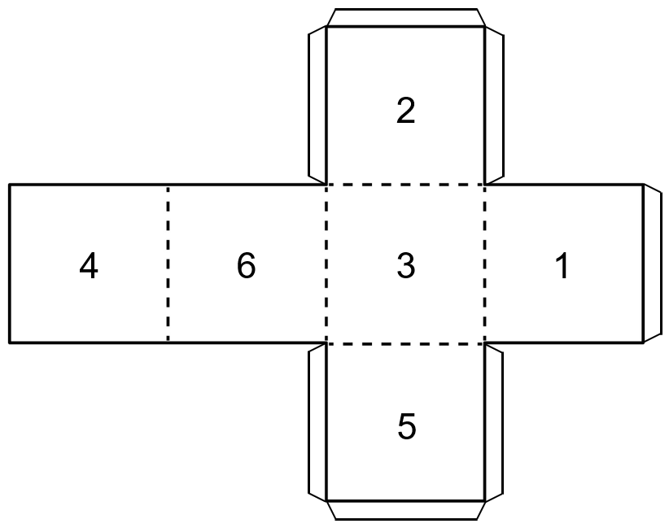

Number Cubes (cont’d)

**Data Management**

**Unit 2 Line Master 8b**

**Number Cube 2**

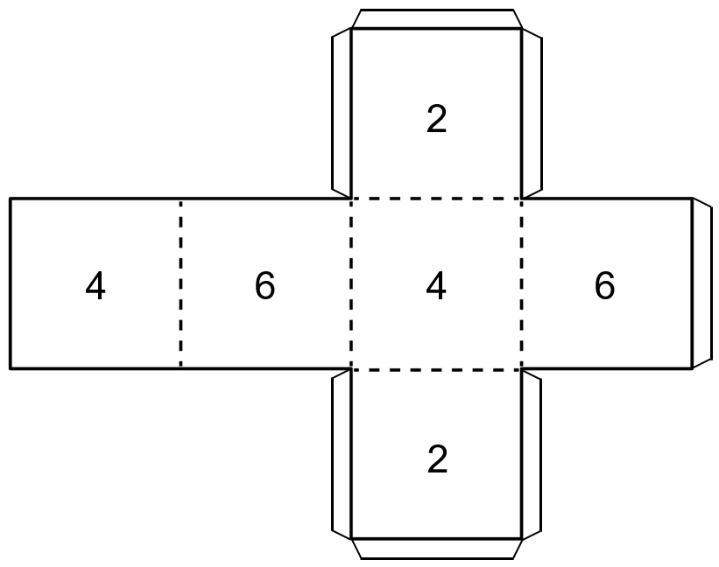

Number Cubes (cont’d)

**Data Management**

**Unit 2 Line Master 8c**

**Number Cube 3**

