Data Management
Unit 1B Line Master 6
Grade 4 Exercise Data

Number of Minutes of Exercise in 1 Day for Grade 4 Students
9, 25, 30, 20, 44, 60, 81, 65, 32, 55, 55, 54, 24, 38, 70, 75, 5, 15,
40, 55, 18, 62, 66, 38, 42, 55, 22, 52

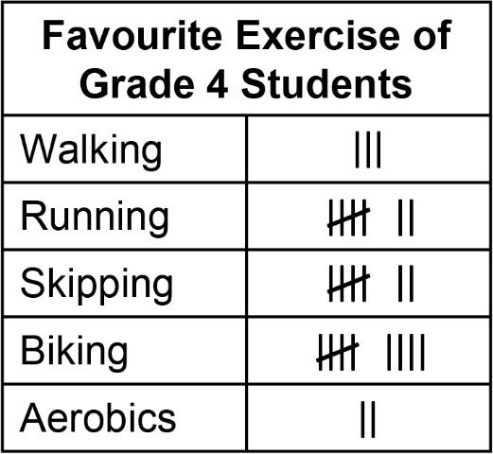

Number of Breaths by Grade 4 Students
Student | Before Exercise | During Exercise | After Exercise
Lamont | 18 | 42 | 30
Abigail | 29 | 60 | 46
Aleena | 24 | 52 | 44
Lenny | 24 | 50 | 43

